Well, it's finally on its own 3 wheels. Next up... motor mounts!

Attached Images
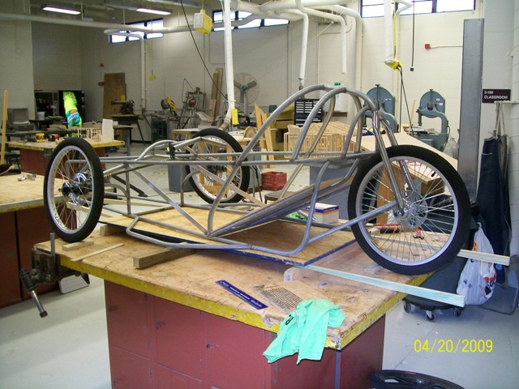

OK, first step to mounting the motor is to mock it up in position. I am using a Briggs & Stratton Etek motor here (Yes, Briggs & Stratton makes electric motors!). After situating the motor where I wanted, I added two crossmembers in the frame to support it. The rear one had to be contoured slightly on the ends to get it back far enough.
After the crossmembers were welded in place, I next fabricated the bottom mounts from 18 gauge perforated angle. Yes, this lightweight stuff supports the motor just fine; electric motors don't vibrate like gasoline engines, so metal fatigue is not a problem. I cut these pieces so they are mirror images of each other, notched them to fit the crossmembers, and then folded the bottom edges upward at a 90 degree angle. The fold adds strength and also keeps the bottom edge from hanging below the frame. I mocked up the motor in place again with the mounts underneath to assure the fit and mark which holes would be used. While the motor was in place I fabricated a tab for the top mounting hole; it's a piece of 16 gauge steel, drilled, and a 5/16 -18 nut welded to it. Then I elongated 4 pairs of holes where the motor bolts down to allow for chain adjustment (I put a red outline around the elongated holes so they would show for the picture).
I mocked everything up again, this time with bolts in place. I squared everything up with a try-square and measuring tape, and tack-welded the mounts in place. Then I removed the motor and welded everything solid. Finally, I reinstalled the motor and bolted it down.

Attached Images
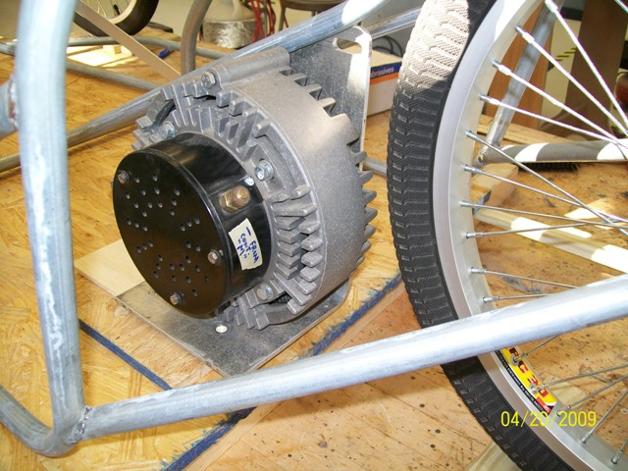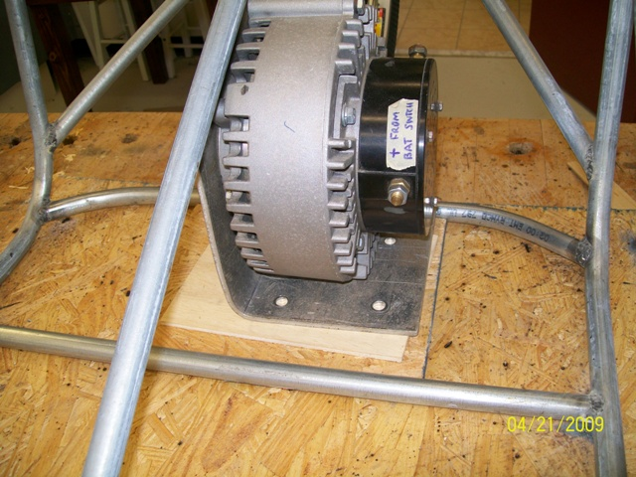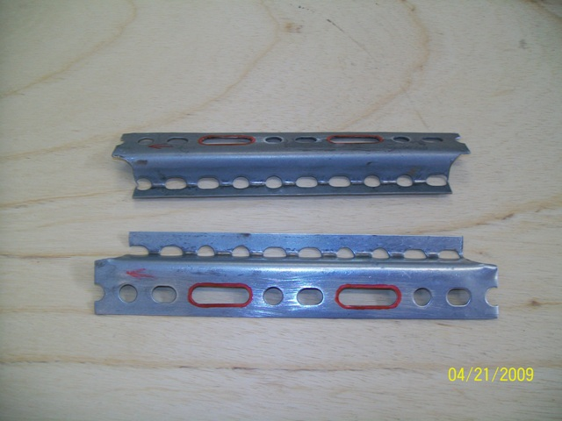
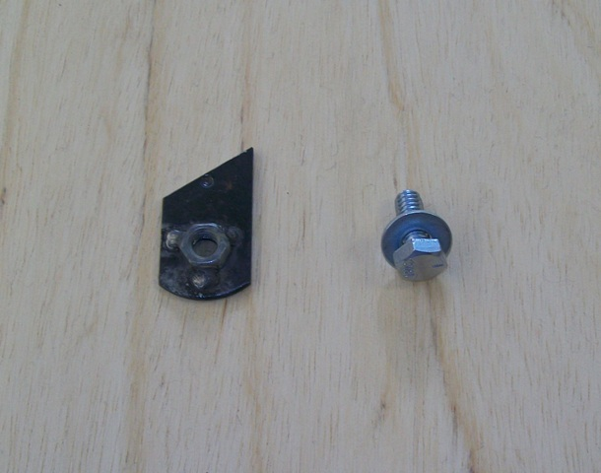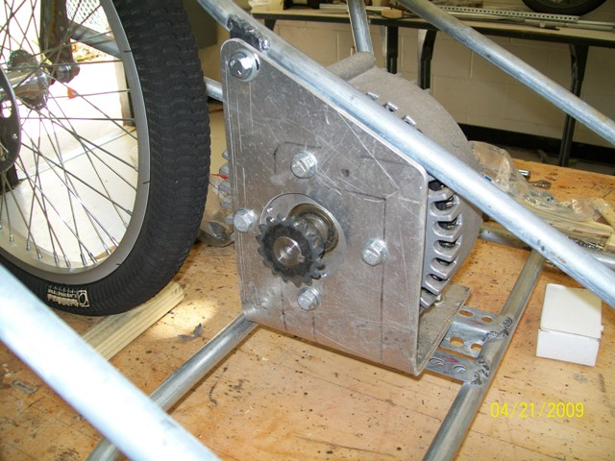

In order to use an electric motor, an electronic motor controller is necessary. Without some type of controller, the motor would either be full-on or off; there could be no intermediate speed, no smooth acceleration, no real control. A mechanical potentiometer big enough to handle the amperage of two Optima batteries in series would be HUGE and heavy. Electronic controllers do the same job, but are substantially smaller and lighter than a mechanical potentiometer. They use a very low power electronic circuit to control the main power circuit. Although controllers can get expensive, the one I am using here is a remanufactured Scott controller that I bought a few years ago for $160. Sometimes, used controllers can be had very inexpensively through golf cart service places. When they get “touchy” at low speeds they are removed and replaced (Little old ladies who play golf don’t like golf carts that have sudden or jerky starts.), but they may be fine for Electrathon.
I located the controller near the motor, but far enough away so if I ever throw a chain it won't be likely to whip the controller. Mounting it was simple; I just fabricated a couple of tabs that match the bolt holes on the controller and welded them to the rear crossmembers.
Attached Images
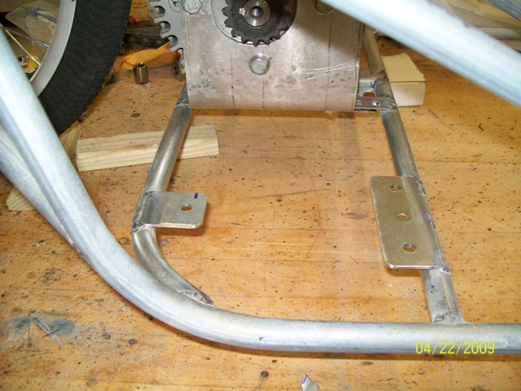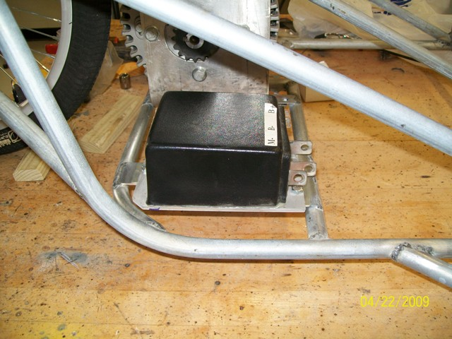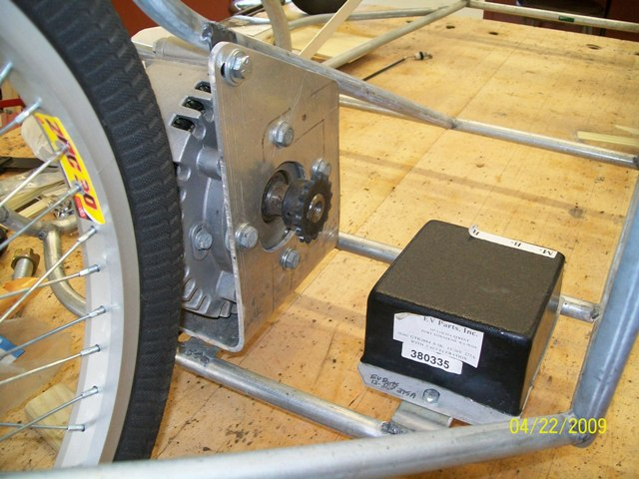

On the silver car and orange car pictured previously, I used 18 gauge perforated angle to make the battery trays. For this car I decided to try something different (and lighter?)...
I bought some 1/16" wall, 1" aluminum angle at the local ACE Hardware. I don't have access to a TIG welder, so I used 3/16" pop-rivets. I cut a piece of angle long enough to go around the perimeter of the battery bottom, allowing 1/4" clearance both directions, plus an extra inch for overlapping the ends. I drilled a 3/16" hole through the fillet of the angle where the bends would be and then made a cut from the edge of what would be the bottom to the hole (see pic). Then I made the bends in a vise with the bottoms of the corners and the ends overlapping. After checking and adjusting for square, I also riveted the bottom of all four corners.
I made eight mounting tabs (four for each tray) from 1/8" x 3/4" flat steel. I drilled and riveted the tabs to the battery trays and then welded the assemblies in place from the bottom of the chassis.

Attached Images
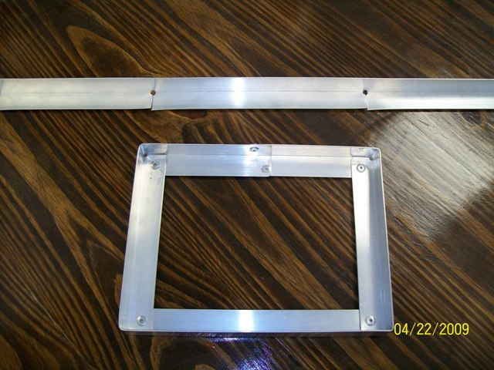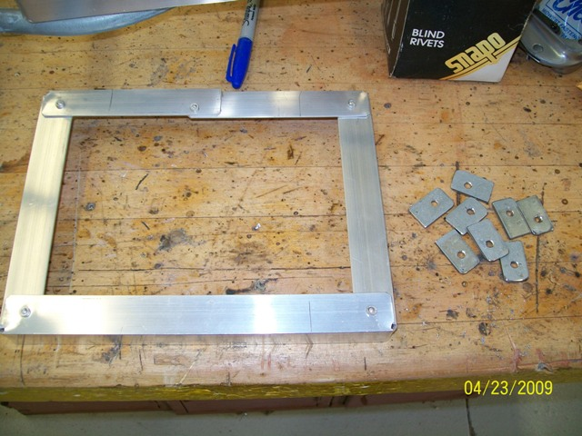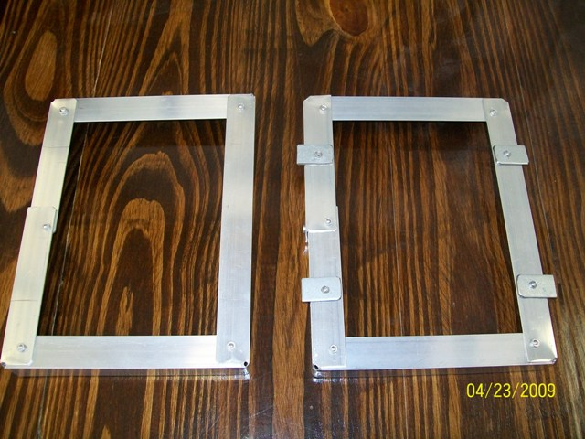
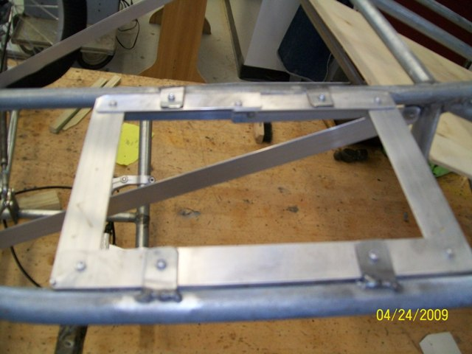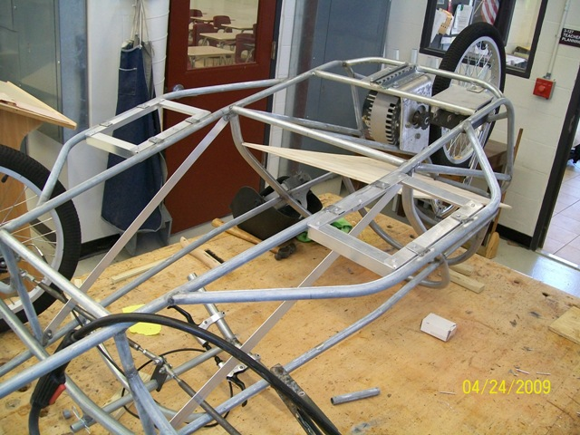

Because of the weight of the batteries, the bottoms of the side pods need additional support along the outside. In this case I used 1/8" steel round stock (welding rod) to make a pair of diagonal struts for each battery pod. The forward ones are welded to the outer bottom rail in front of the battery tray and to the top rail near the steering wheel crossmember. The rear ones are welded to the outer bottom rail behind the battery tray and to the main roll cage hoop.
Attached Images


