Steering is next! A lot of Electrathon cars have twin-lever steering because entry and exit of the car would be difficult or impossible with any type of steering wheel in the way. In this design, however, a steering "wheel" is not only possible, but preferred. It works just like the steering seen on most Go Karts; a shaft, "wheel", pittman arm, and tie rods.
The first step is to locate where the steering shaft will go. To do this, I used a piece of conduit about 4 feet long. I put one of my students in the car and determined the approximate height and angle needed for the shaft. Then with the long shaft propped in place with a piece of flat stock and a folded rag, I was able to tack-weld the upper sleeve in place.
Next, I fabricated the pittman arm from 3/16 x 1 1/4" flat steel. I have to admit here that I actually made this piece three times before I got it right. The one in the unassembled pic is the first one and it was too short. The second one was also just a bit too short. Finally, on the third try I got it long enough. I also cut the conduit shaft down to a useable length.
The tie rods are fabricated from 1/2" O.D. tubing (bought at ACE Hardware) with a 1/4-28 grade 8 bolt welded to the end. At this point, the pittman arm is still not welded to the shaft.

Attached Images
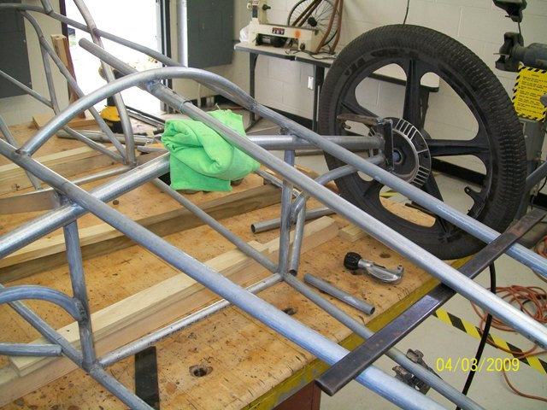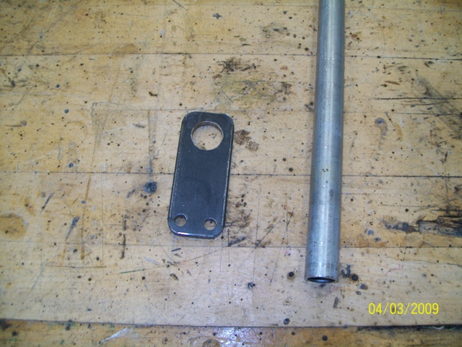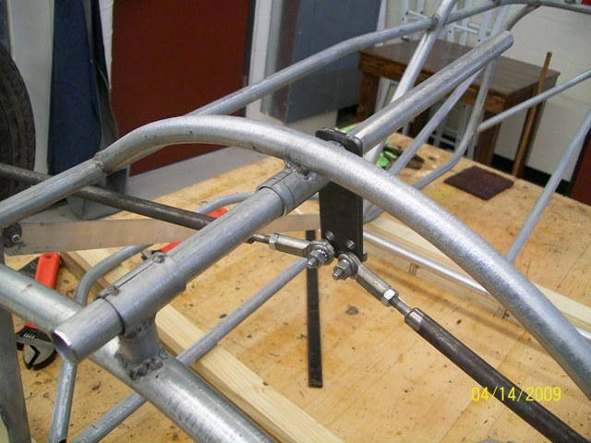
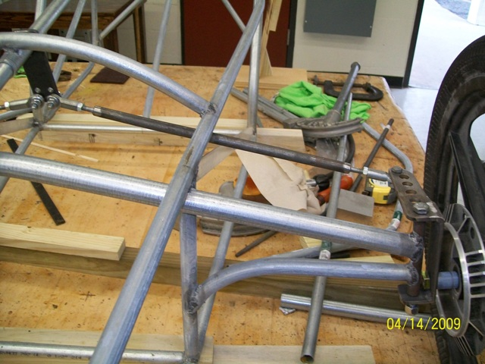

With the major components all fit, it only takes a couple more steps to finish the steering. I first welded the pittman arm to the steering shaft. I only welded it on the side away from the sleeve so that it won't grind into it and cause unnecessary wear and binding.
Next, I fabricated the "wheel" (actually more of a bar because of space limitations) from a piece of 3/4" conduit cut to 14 inches in length. I notched it in the center so that I could bend it about 10 degrees and welded it. This serves two purposes. First, it helps to keep the ends of the "wheel" inside the cowling when turning. Second and more importantly, it makes gripping it more comfortable. After climbing up on the table and slithering my fat self down into the chassis, I held the steering "wheel" where I felt it was comfortable and marked the location on the shaft. Then I climbed out, removed the steering shaft, cut it to the marked length, and welded the "wheel" to the steering shaft. Care must be taken here to make sure the "wheel" is perpendicular to the pittman arm.
Finally, I reassembled everything and then drilled a 1/8" hole horizontally through the shaft and secured it with a hitch pin (arrow).

Attached Images
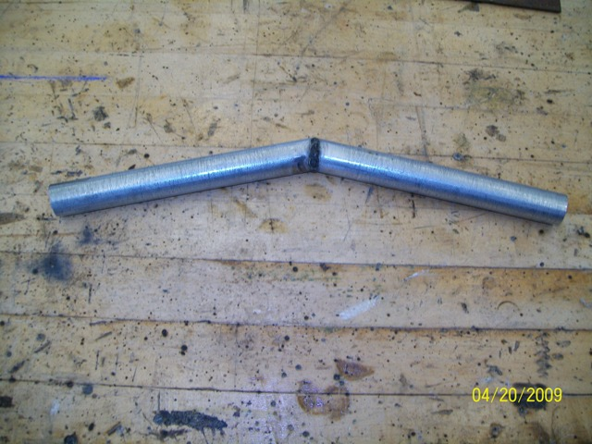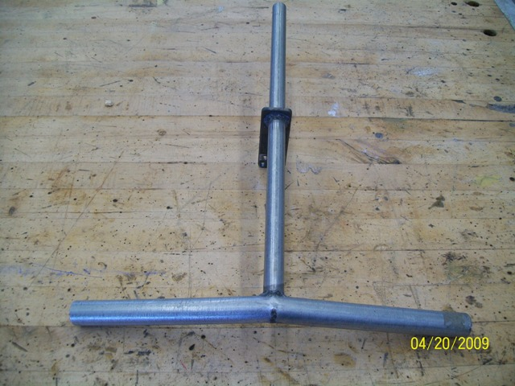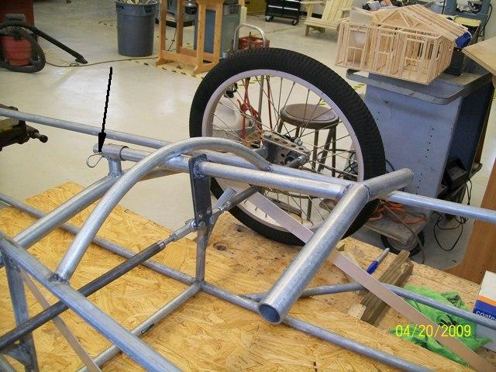

Brakes are next! Electrathon rules state that brakes are required on at least two wheels on the same axle. On a tricycle car it is easy to use ordinary rim calipers on the rear wheels. It becomes a bit more difficult on a cycle car because there is no fork assembly or framework where a rim caliper can be mounted on the front wheels; the brakes must be mounted at the spindles. In the past we commonly used Arai drum brakes on these cars. Unfortunately, Arai stopped making those over a year ago and they are no longer available. The obvious alternative is some of the newer (and more effective) disc brakes...
After assembling the discs to the wheels and the wheels on the spindles, I held the brake calipers in place, one at a time, to determine what kind of brackets would be necessary. A little rummaging through the junk cabinet netted an 8" corner bracket that is made of 14 gauge steel - perfect!
The bodies of the calipers are cast in an offset configuration to accommodate the fork mount on a bicycle. Therefore, in order to get the calipers in their correct positions on opposite sides, the brackets are different. I started by making patterns from poster board. The one for the right side was easy and accomplished on the first try. The left one was somewhat more difficult; I configured and cut it out four times before I got it right...
Once the bracket patterns were transferred to the steel, holes drilled, and shapes cut out (with a hacksaw and grinder), I bolted them to the calipers. Next challenge was to hold them in place and mark their locations on the spindle knuckles. Once satisfied with my marks, I disassembled the calipers from the brackets and the wheels from the spindles. Then I was able to clamp the brackets in place according to the marks and weld them in place. Finally, I reassembled everything and checked for smooth operation.

Attached Images


