Building an Electrathon Car From Scratch by Jim Robinson – Revised January-February 2025
Introduction
Although Electrathon is a great project for high school students, it is not limited to them. Anyone 14 years of age and older, with approval of the race officials, can participate in Electrathon and there is no mandatory retirement age. The races are "enduro style" which means that we race for a specified length of time (usually one hour). Whoever completes the greatest distance (most laps) in the designated time is the winner.
After the initial expense of obtaining or building a car, the upkeep and maintenance is really low cost. Most of the cars run bicycle tires in the $18 to $35 price range; how long they last depends on the quality of the tires and the surface we race on. Lube the chain, charge the batteries, slap on a couple of fresh tires and go race. At the end of the day we usually have spent $40 - $60. When I was racing stock cars, that wouldn't fill the fuel tank and tires were $120 each. By comparison, Electrathon is just good inexpensive fun...
The pic below is the start of a race a few years ago. The copper-colored car in front is my son, the car directly behind him is the original prototype car of this design, and at the back of the grid is me in the black #13.

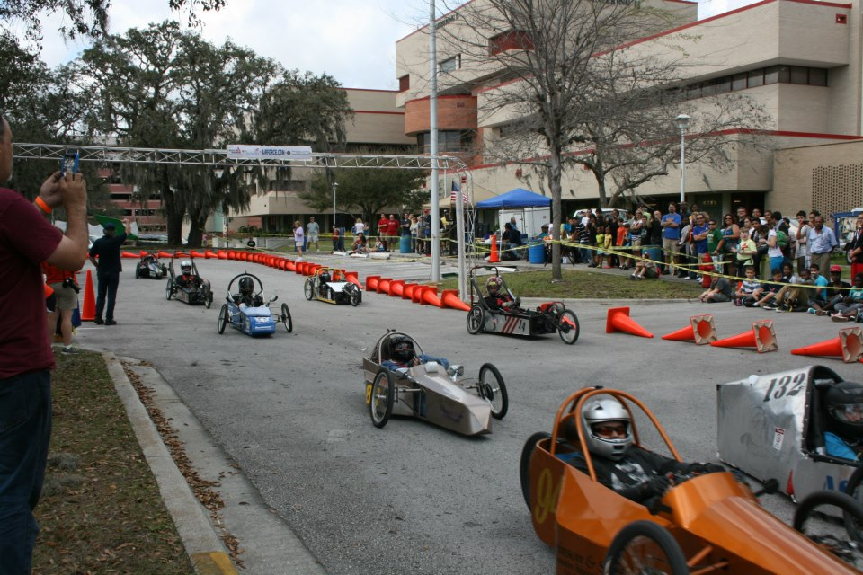

This is something that I got involved with back in 2002 with my students. For those reading this that may not know, Electrathon is a competition for purpose-built electric powered vehicles. These are not little toys or R/C cars; they are 3 or 4-wheeled vehicles that you can get in and drive. These also are not the $100,000+ solar experimental cars that race across country every Spring. An Electrathon car may be built from a kit or completely scratch built. Although the kits can get pricey, depending on options, I have seen some very good competitive cars built from scratch for around $800! The final cost depends greatly on the ingenuity and skill set of the builder.

The cars are technically interesting and sometimes aesthetically appealing, too. Most of all, they are a lot of fun to drive. Being an old stock car racer and hot rod builder, I am accustomed to internal combustion engines that have to turn up some RPMs to generate horsepower. Boy, did I have a lot to learn when I started playing with electric motors! Come to think of it, I’m still learning...

Since 2002 I have personally built and sold over 20 cars, plus they have been copied a couple of dozen times with my permission and blessing. I am frequently asked how I do some piece or part of a build. I have no secret ingredients or special knowledge, just common-sense solutions to the problems. My methods come from my experience as a fabricator/welder and exposure to several types of racing since childhood. Follow along on this thread and see how a car is built. For more info on Electrathon cars and events, check out the Electrathon America website: www.electrathonamerica.org
The objective in Electrathon is to complete the most laps in a given amount of time (usually 1 hour). In the Standard Battery class we are limited to 73 pounds of lead-acid Gel Cell or AGM batteries or we can use two batteries off the approved list. For several years, my team used two Optima Yellowtop batteries wired in series for a 24-volt system. There is also a class for Advanced Battery cars using Lithium, NiCad or other modern batteries. They have different battery weight limits. Each car in all classes must carry a 180-pound payload (payload is defined as the driver plus ballast, if necessary, to equal a minimum of 180 pounds). There are races held at real racetracks occasionally, but most of the courses we run on are temporary parking lot venues. All you need is somebody to race against and a place to do it and you can hold an Electrathon race.
Innovation and ingenuity are the name of the game in this sport. Although most of the cars are capable of speeds in excess of 40 or even 50+ mph, because of the tightness of the short courses and the need to conserve the limited battery power, race speeds are usually only in the 22 to 28 mph range which makes this a fairly safe sport. Even so, competition is sometimes close and fierce. Here are some typical cars (below):

Pic 1 is a Blue Sky Designs Aerocoupe. This was a very popular kit car a few years ago. It is of the "cycle car" type, meaning it has two wheels up front and one in the rear. They are aerodynamic, light, mechanically simple, and very reliable, but the design is old and dated. The cockpit is small and cramped and the wheels are plastic! Worst of all, they were a bit pricey for what you got.

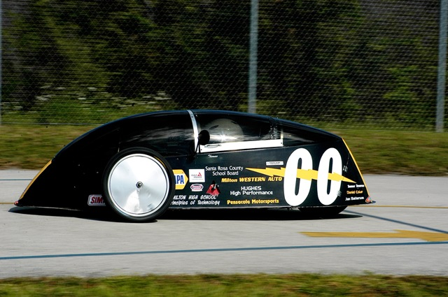

Pic 2 is a front-wheel-drive car. Note the motor is mounted on the front fork. Batteries are behind the driver and the driver sits well back in the car. This is a tricycle design (one front wheel, two rear). Tricycle style cars have a tendency to roll over if the weight is not kept centered between the rear wheels. If you've ever ridden a three-wheel motorcycle, you may know what I mean.

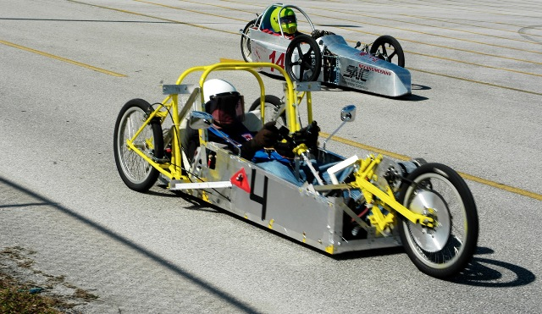

Pic 3 is one of my cars from 2015. This is a cycle car style and the driver reclines way down low. It was originally designed with independent front suspension, but after reliability problems with the original prototype, I changed the design to rigid suspension for better reliability and less weight.

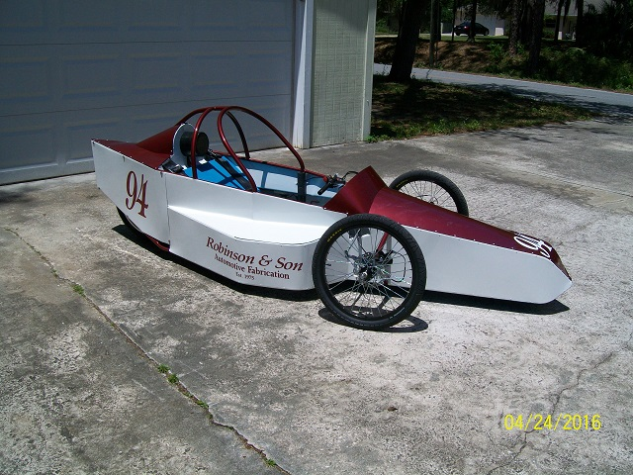

Pic 4 is one I built for myself in 2004. It is cycle-car style and included a six-speed derailleur. After a few races I determined the derailleur was useless and deleted it from all subsequent cars.

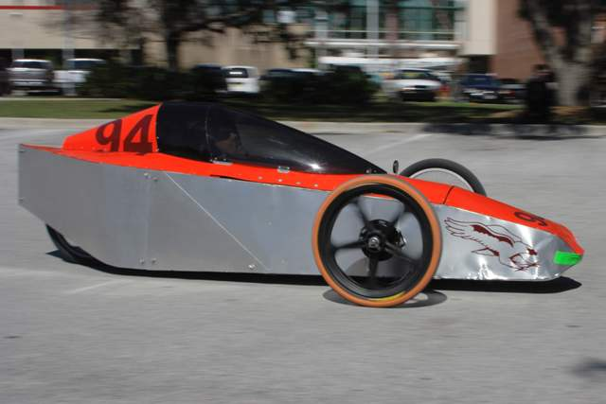

Pic 5 is a “leaner” car. It is made to lean into the corners. It was powered by a 1 hp Scott motor, used a six-speed derailleur, and the chassis is suspended and linked to the steering so that it leans into the turns. It was successful for a while, but its only real advantage was reduced stress on the spokes and reduced wear on the tires. Maintenance and unreliability of the complex linkage system made it impractical for most builders.

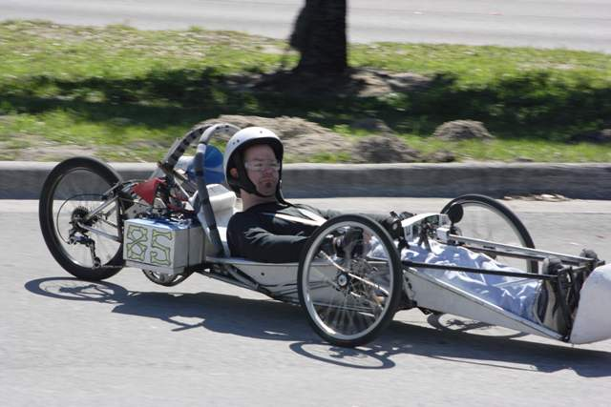

The Build

Chapter 1: Getting Started

OK, this is supposed to be a build thread, so let’s get to it. If I seem wordy it's because I want to explain everything as best I can to those who have never been exposed to this type of thing before...
First requirement is to decide which type of car to build. Of course, we could build a conventional 4-wheel car, but since friction is a consideration, eliminating the rolling friction of one tire on the ground is a 25% reduction in bearing and tire friction and seems to be the way to go. The simple fact that probably more than 95% of all Electrathon cars are 3-wheeled lends credence to that practice. So.., with that in mind the next consideration is whether to make our 3-wheeler a cycle-car or a tricycle.
Folks who have ridden conventional 3-wheel motorcycles know that, in a tight corner, those things will flip over at relatively low speed. The problem is that the high center of gravity (CG) transfers forward and outside the triangle formed by the three contact patches of the wheels. In order to stabilize a tricycle in a corner, it is necessary to get the CG down low and between the rear wheels. To do that, we need to stretch the wheelbase and move everything down and rearward. One of the winningest teams in Electrathon, Cloud Electric, successfully uses the tricycle configuration, but up in the Northwest they run mostly on long road courses or large ovals.
On the tight parking lot "road courses" we run most of the time here in Florida, quick handling is important. With a cycle-car configuration we can keep a shorter wheelbase for quick steering response, move the CG around pretty much at will to put components where we want them, and still not worry about the car having a tendency to roll over. I have video of one of the Kennedy High School cars from Iowa actually smoking the rear tire in a tight turn and all 3 wheels stay firmly on the ground. So, it is a cycle-car style that we will build here.
I have an advantage in that I have done this before. The car below, the original prototype of my “Silver Bullet” design, was originally conceived by my students and me, the design refined by me, and built by my students and me. That was in 2004. Since then, this car has proven itself to be reliable, consistent, and driver-friendly. It is still in competition at this writing and still very competitive! The car I am building here is similar to this, but with a few refinements I have learned along the way.

