Chapter 13: Final Details

Back near the beginning, I cut a "temporary" seat back from Luan plywood. It's light enough and rigid enough to be made "permanent" so here's what I did. First, I riveted a strip of 1/16" x 1" aluminum across the seat back area. Next, I split the "temporary" seat back down the middle. Finally, I hinged the two halves together with duct tape. Now I can easily remove the seat back for easy access to the motor and controller. After 22 builds I still do this the same way. It’s light, simple, inexpensive, and it works.

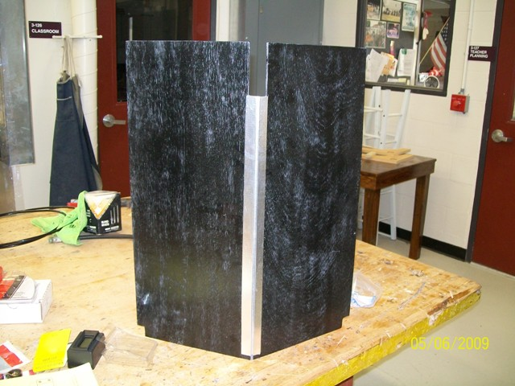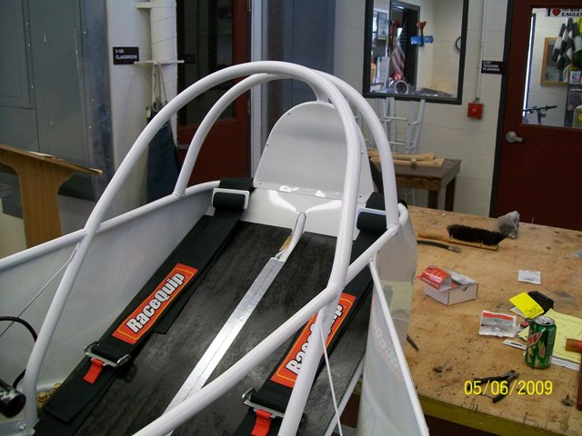

I didn’t cover the installation of the safety harness – different ones sometimes have different manufacturer’s instructions. By Electrathon America rules, you must have a minimum 5-point harness. The two washers welded to the bottom frame rails earlier are for the lap belt. The shoulder harness straps are attached to the upper crossmember behind the driver, the anti-submarine strap is bolted to the seat pan between the driver’s legs with a large fender washer under the floor. For that (and anything else that’s bolted through the bottom of the car) I use button head bolts with the threads pointing up and the nuts on top. The reason for doing it that way is because the rules state that the car, with driver, must be able to roll over a 1½-inch thick block without snagging.

If you have reached this point with your build, you’re almost ready to race… or at least test drive it. To make the car drive and steer freely, the front end needs to be aligned. Front end alignment is the relationship of the front wheels to each other – in other words, are they aimed in the same direction? Front end alignment is important on these cars to keep rolling friction to a minimum. To get the toe set correctly, I use this method that I borrowed from my stock car racing days. I made this pair of alignment boards in just a few minutes and they can be used for years.
I began with some old shelving I scrounged from a renovation project. This is 3/4" birch-faced plywood, but I could have used ½-inch plywood or any flat, rigid material. I cut two rectangles the same size (11" x 24"). I screwed them together temporarily so I could cut them the same. I used a screw, string, and pencil to mark a half-circle on the top piece. (Yes, I marked it twice. The first time wasn't big enough.) After cutting the half-circle out on the band saw, I marked and bored two holes equal distance from the bottom corners. I used a 2" Forstner bit, but this could also be done with a hole saw. With all the cutting done, I removed the screws so I then had two identical pieces.
Using these boards is easy. To set the toe, I put one of the boards against each front tire sidewall. If I’m working without a helper, I secure them with masking tape. I put a pair of identical tape measures through the holes. Now the toe can be set by comparing the readings on the tapes. I use 1/16" toe-in on my cars. Some folks like toe-out, some like 1/8 inch instead of 1/16. The final setting is up to you.
These boards also work on full-size cars, too; I have used these on my ’31 Ford coupe hotrod and have made duplicate sets of these for friends to use on their cars, also.
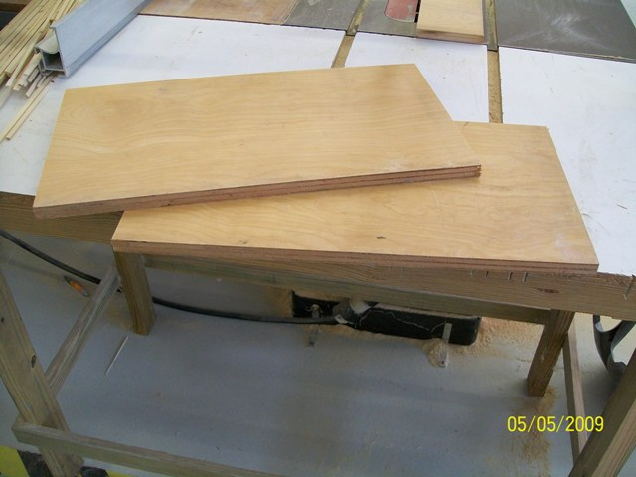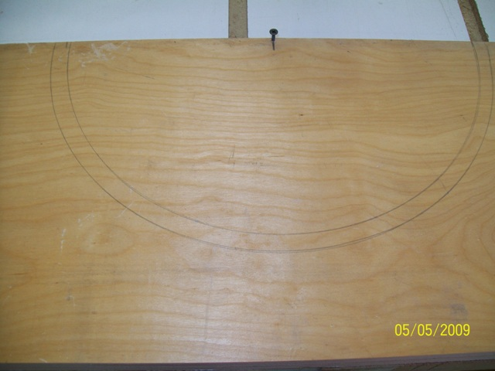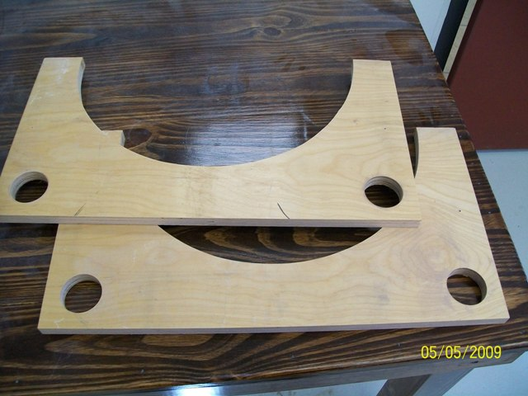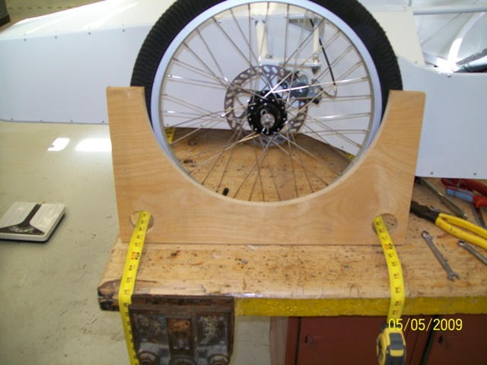

Electrathon America rules require that we have rear-view mirrors. The viewing area must be at least 8 square inches. I get 2.5 or 3-inch diameter convex “fisheye” mirrors at the auto parts store and mount one on each side of the car. (The little 2-inch mirrors are not big enough – calculate the area of them 3.14 square inches each.)

I make a simple mount from 1/8” x 1” aluminum flat bar. Your brackets may need to be different, depending on the design of your car and the height of your driver, but for mine I start with a piece 9 inches long. I mark 2 inches from one end and bend the bar 90 degrees. I drill two 3/16” holes in the short section (bottom) and rivet them on the car’s top frame rail, opposite sides, where I want the mirrors. Finally, I peel the paper film off the self-stick pad on the backs of the mirrors and stick them on the aluminum supports. To make sure they stay, I cut circles out of duct tape and stick them to the backs of the mirrors.

The sticky tape grabs onto the sticky mirror pad, trapping the aluminum between them. In 23 years of racing in Electrathon (at this writing) I have only had one mirror come off during a race. That was on a track so rough that several cars had much worse problems.

If you want something a little more aerodynamic, here is something I have done a few times. I began by making a pattern from poster board. Once again, I made the pattern more than once before I was satisfied with the shape and fit... Next, I transferred the shape to a piece of aluminum. I traced the pattern once, then flipped it over for the second piece so they would be exactly opposite each other (one for each side).
To form the flanges on what would become the bottom of the mirror nacelles, I used a piece of hard wood with a straight edge and a rubber mallet.
I formed the shape of the aluminum pretty much by bare hands. The stuff bends pretty easily, so I just kept working it until I got the shape I wanted. When I was satisfied with the shape and had them as identical as I could get them with "calibrated eyeball", I installed the new nacelles in front of the mirrors by riveting them in place.

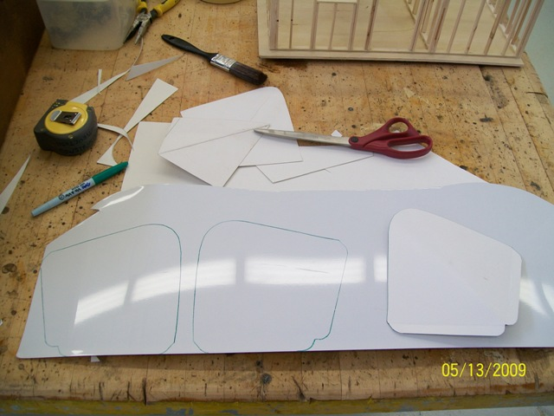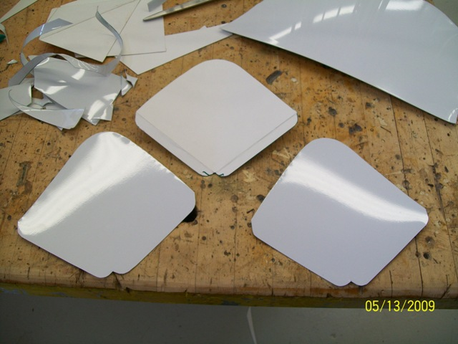

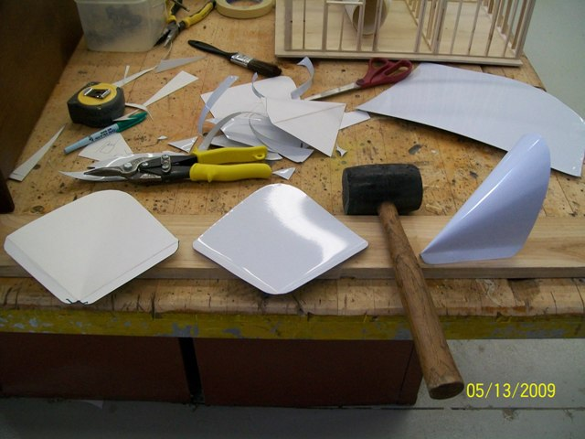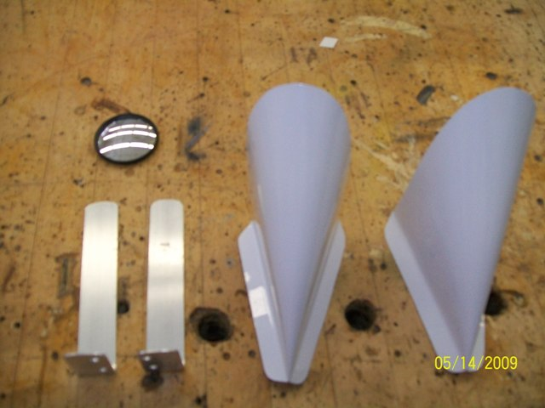

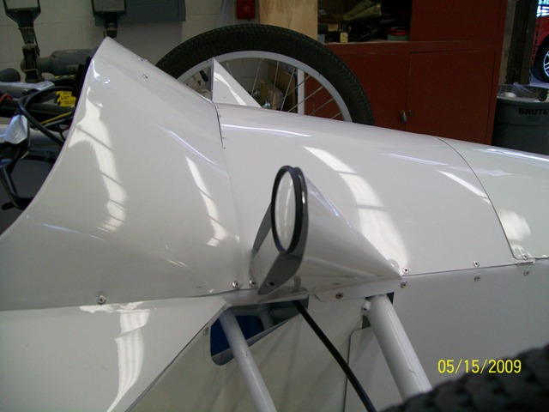

Below are a couple of shots of me with the car so you all can get a better idea of the size of it. As you can see, the top of the roll cage is just below mid-thigh on me (I am just shy of 5'10"). When I am in the car, I am almost fully reclined. The seat back is 30 degrees from flat. It's a close fit in there, but it's fairly comfortable. When I have my helmet on, my head is propped up just a bit more. The design has evolved since the pictured car in 2009. I raised the roll cage 2 inches to ease the driver’s entry and exit with helmet on and widened the roll bar at the driver’s elbows for more comfort. I changed the shape of the side pods, purely for appearance, and I added the streamlined tail to improve aerodynamics on large tracks. Overall, though, the basic design has remained the same; wheelbase, tread width, and nose shape stayed the same. I am very pleased with the way it turned out and its success on the track.

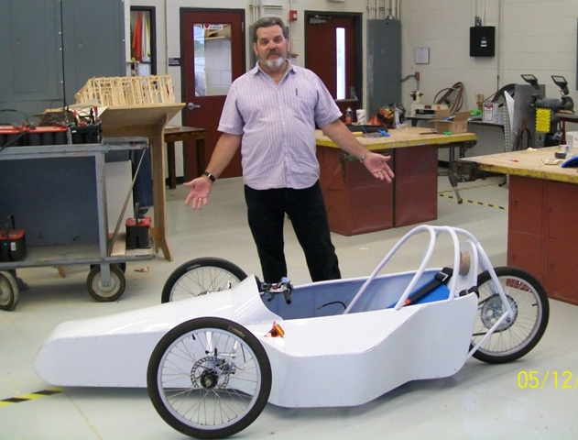

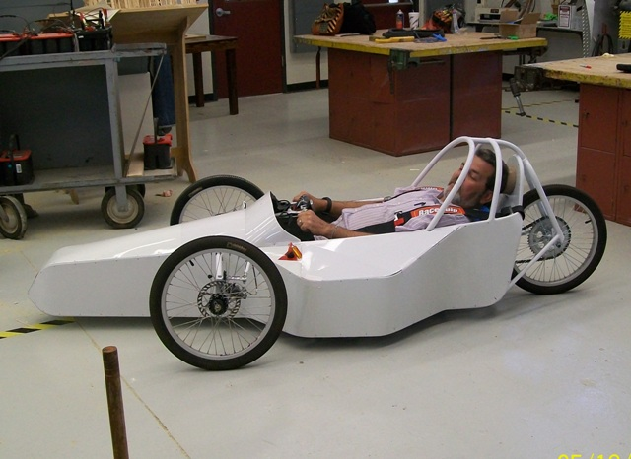

Here are some of the cars, from bare frames to finished cars, that I have built for myself and other Electrathoners. Aside from my “Silver Bullet” design, I have also built other style cars. All of them have had some success on the track, but the reliable old Silver Bullet has been the standout of the bunch. The silver number 14 car (first pic) is still racing competitively; it’s orange now and 21 years old at this writing (February 2025). The number 4 Tiger Racing car (second row, 4th pic) is the most successful winning car in Electrathon Florida history. Now in its 13th season, at this writing, it is still winning frequently.

