Chapter2: Construction Begins

When we designed the original Silver Bullet car, I put a student on a table with his legs stretched out straight and a board under his back. I propped the board up with books until he could easily see over his toes and his hands with his arms held straight out forward. Then I started taking measurements. I did a similar process with my orange car (previous page), but I propped up the "driver's" knees with a bar to simulate the front axle under his knees and then propped up his back until he could easily see over them. In both cases I did a quick diagram with measurements. Then it was time to start building...
The next step is to acquire something to build with. Some of the well-healed teams in the Northeast use some pretty exotic materials in their builds like carbon fiber and Kevlar, but I was always on a budget and had to stay a bit more conventional. I wanted to use materials that are readily available and easy to obtain. I made a trip to the local Lowe's and picked up some EMT conduit. I got ten 10-foot pieces of 1/2 inch and two pieces of 3/4 inch. I also grabbed a roll of aluminum "kick panel" from the area where they have siding and porch screen stuff. The aluminum is .024" thick, 16 inches wide and 16 feet long. Later I discovered I would need go back for a second roll of the aluminum.

I did some poking around in my old files and came up with this diagram I sketched in 2004 when we built the silver car on the previous page. It obviously is not to scale and the human form is not reclined as much as the dimensions indicate, but it gave me some measurements to work from. The student I used as my “model” was 6'3" tall. Once we had his back supported at the desired angle, we started taking measurements. I measured from the bottom of his shoes to approximately where his tailbone would contact the table. I measured the height of the plywood at the top of his shoulders so I could make the seat back. I measured to the front of his shoulder so I would know how high to make the sides. I measured to the top of his head so I would know how high to make the roll bar. Etc, etc.
I'm sure I must have made a preliminary sketch of the frame before I started building, but it apparently did not survive.
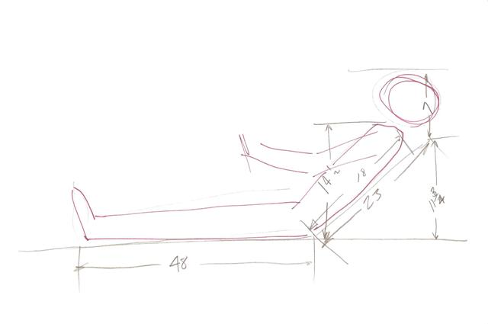
The first car I built was done on a workbench and the floor. When I began this second car, I decided it might be prudent to build some sort of frame jig. It’s a good thing, because I have since built over 20 cars on that jig and have also duplicated the jig for other builders!
After building over 20 cars of this basic design and tweaking a few details over the years, the chassis diagram looks like this:

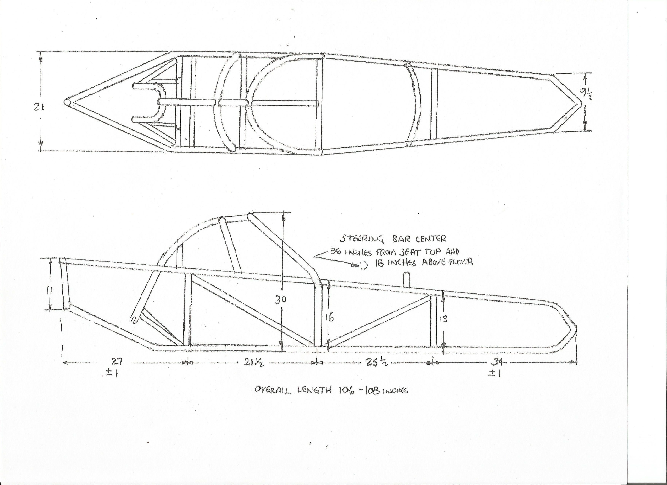

Not shown on this drawing are the side pods. The batteries are housed in the side pods which gives the Silver Bullet its almost perfect weight distribution. For that you can look at pictures of the finished cars and design your own shape.

OK, the first step in construction is to make some preparation. As noted earlier, I already picked up the conduit for the frame. Next, we need a few tools; in addition to a welder and a few other usual fabrication tools, we need a couple of conduit benders (1/2" and 3/4"), an ordinary framing square, a tape measure, and a tubing cutter. Also, not pictured, we'll need a chalk line, a combination square, a speed square, aviator snips, and an assortment of clamps and vise-grips. For materials to begin with I obtained a sheet of ½ inch plywood and some 1” x 3” lumber.

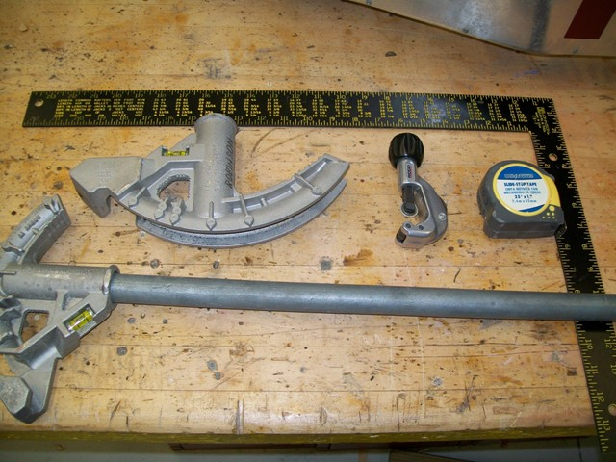

I began by splitting the sheet of 1/2" plywood down the center (24" x 96") and laying it across two tables. This would become my frame jig. Later on, I framed the underside of the jig with the 1” x 3” lumber so it could be used sitting on “saw horses” instead of blocking the use of the two tables.
Next, I struck a chalk line down the center of the plywood. Using the chalk line as the center line of the vehicle, I used the tape measure and framing square to lay out some key points. Then I used a straight-edge and pencil to "connect the dots" and end up with a rough outline of the frame on the plywood.
I cut some small pieces of scrap 3/4“ thick wood to make "fixtures" or "stop-blocks" and screwed these to the plywood in some key locations. More precisely, I put the "outside" blocks right against the pencil lines and then used a piece of 1/2" conduit to locate the "inside’ blocks (see pic below). Finally, I was able to start fitting and bending some conduit.
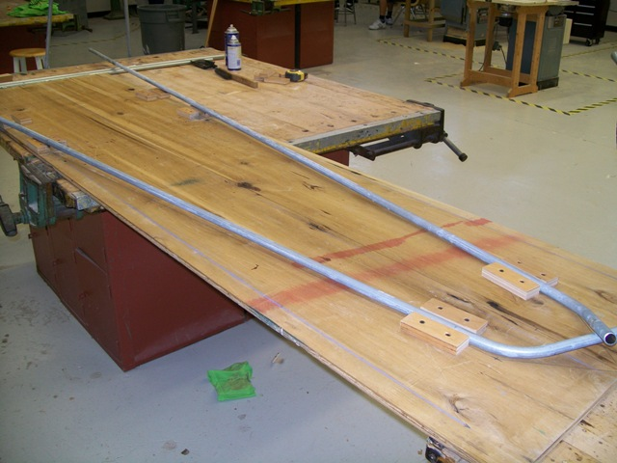

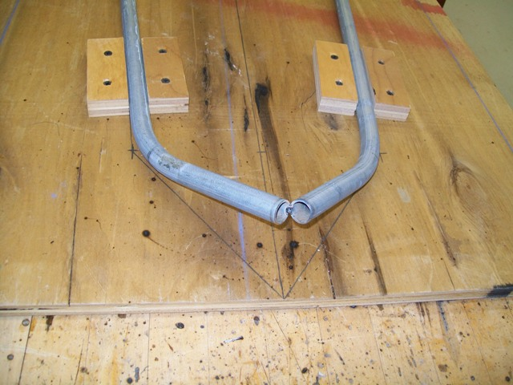

OK, notice in the pics above that I bent the front of the conduit so that the pieces will come together at the front. They are positioned so that they come together and also turn slightly upward.
I determined, by measuring several students, that to accommodate the shoulders of an average person, the width of the car needs to be 21 inches at the shoulders. On the original car, we tapered from the rear cockpit cross member forward. However, at the area of the driver's elbows the width has shrunk down to a little over 17 inches. That's fine for a driver that is of slender build, but from driving that car myself, I have determined that comfort would be improved if I maintain the 21-inch width at least to the area of the driver's elbows. With that in mind, that is how I laid out the outline and set the stop-blocks on the plywood jig.
With a very slight bend at the "elbow area", the conduit lays in the jig like it should. I used some pieces of 1” x 3” lumber and some clamps to hold the pieces in place. This was not clamped tightly enough to damage the conduit, just tight enough to make sure the pieces stayed flat on the jig while I did some welding. I then tack-welded the front of the conduits together and cut, fit, and tack-welded a crossmember where the back of the seat will be.

At this point I also formed the main hoop of the roll cage from 3/4-inch conduit. Bending the roll cage hoops can be a challenge... I first did it by bending the conduit a little, sliding it through the bender, bend a little more, sliding back and forth, bending a little at a time, repeat, repeat, repeat until I got the shape I wanted. After the first couple of cars I fabricated a bending jig so I can bend the roll bar hoops in one continuous bend. I got a piece of 20 inch x 60 inch shelf material from the local Lowe’s. I marked and cut two identical pieces using a 19 inch diameter circle as the basis (it was pure guesswork on my part, but I got lucky – because the tubing springs back a little, it makes hoops exactly 21 inches across). I routed the edge of both pieces with a 3/8-inch cove bit, and then glued and screwed them together, face to face, so I ended up with a big form with a groove around it for the ¾ inch conduit to fit in. Last, I added a piece of steel strap bent over and bolted through the wood to hold one end of the tubing.

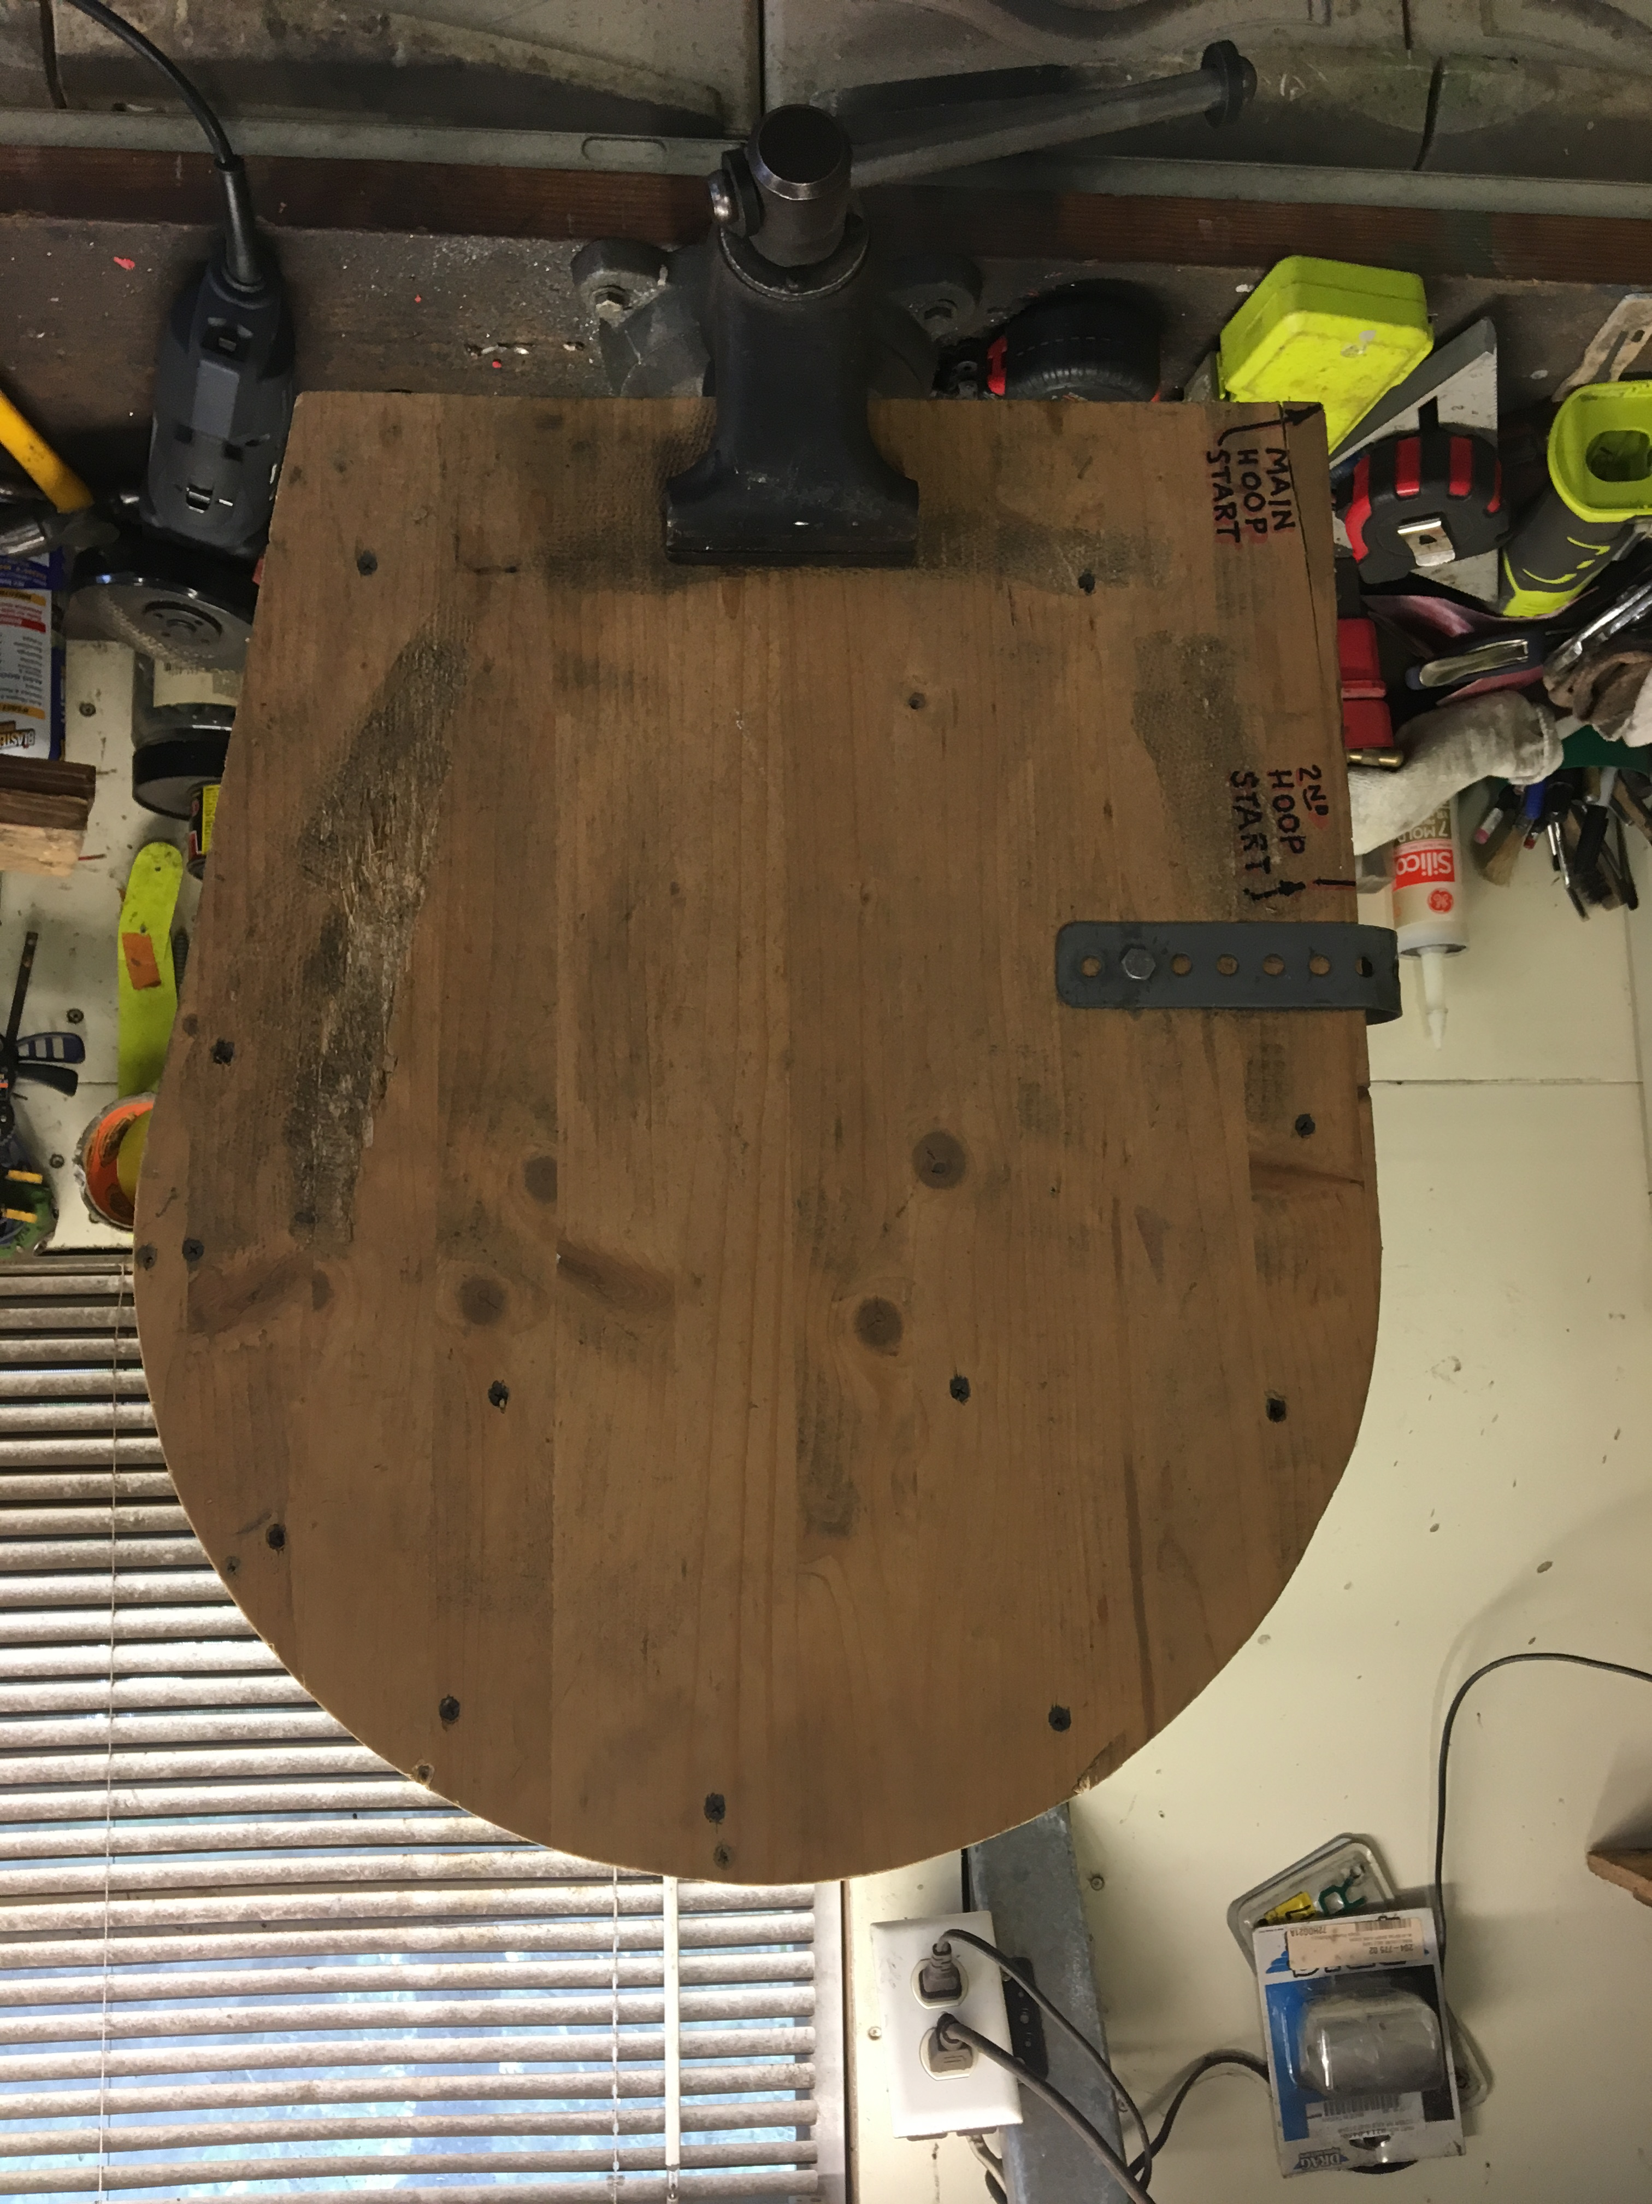

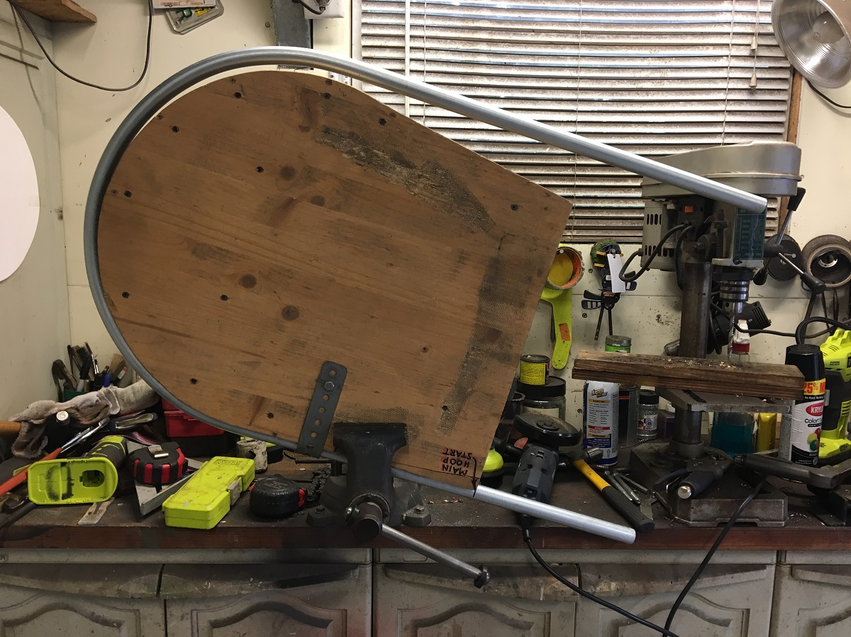

Notice that the tubing springs back a little; that’s why the bending jig is slightly smaller than the finished radius of the bent tubing and also allows the tubing to be bent about 8 – 10 degrees past 180 degrees.

Of course, your car will have its own dimensions depending on your design, but in this case, I start with a piece of ¾” conduit 80 inches long. I put a mark 10 inches from one end and that is my starting point. With the fixture clamped in a vise, I insert the tubing and bend it around the fixture.

I use marks on the bench or on the floor to determine if the “legs” of the hoop are the same length. If they are not identical, I use the tube cutter to shorten the long leg to match the shorter one. Next, I put marks 14 inches from the ends and bend them to the desired angle (45 degrees for my cars).

The picture below shows two roll bar hoops; one just from the form, the other with the legs bent to the finished angle.

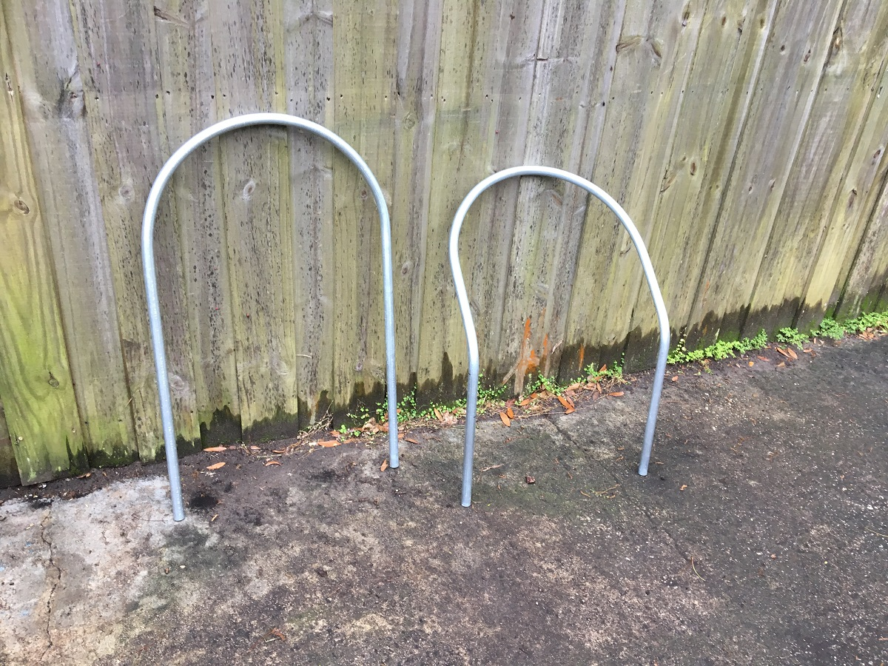

The seat bottom back crossmember and the bottom of the main roll bar hoop converge at the same place. I prop the roll bar at the intended height and weld the bottoms in place.
