Chapter 3; Upper Frame Rails

In the picture below you can see the main roll cage hoop propped up with the framing square and a couple of small blocks under it. This was the first car built on this jig. Also note that the bottom tubes are bent upward. The first several cars I built were open at the rear.

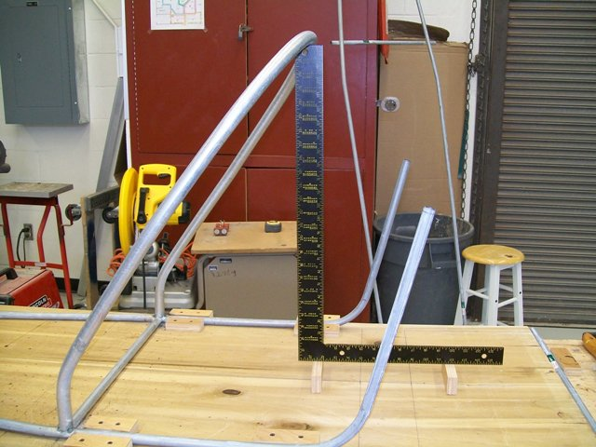

On subsequent cars I used a prop I made from a 2 x 2 and a small scrap of plywood to hold the roll bar at the correct height. Also, notice by comparing the picture above and the one below, that I moved the bends up higher on the roll bar. This makes fitting and welding the upper frame pieces easier, but the main reason is it provides better side protection for the driver.

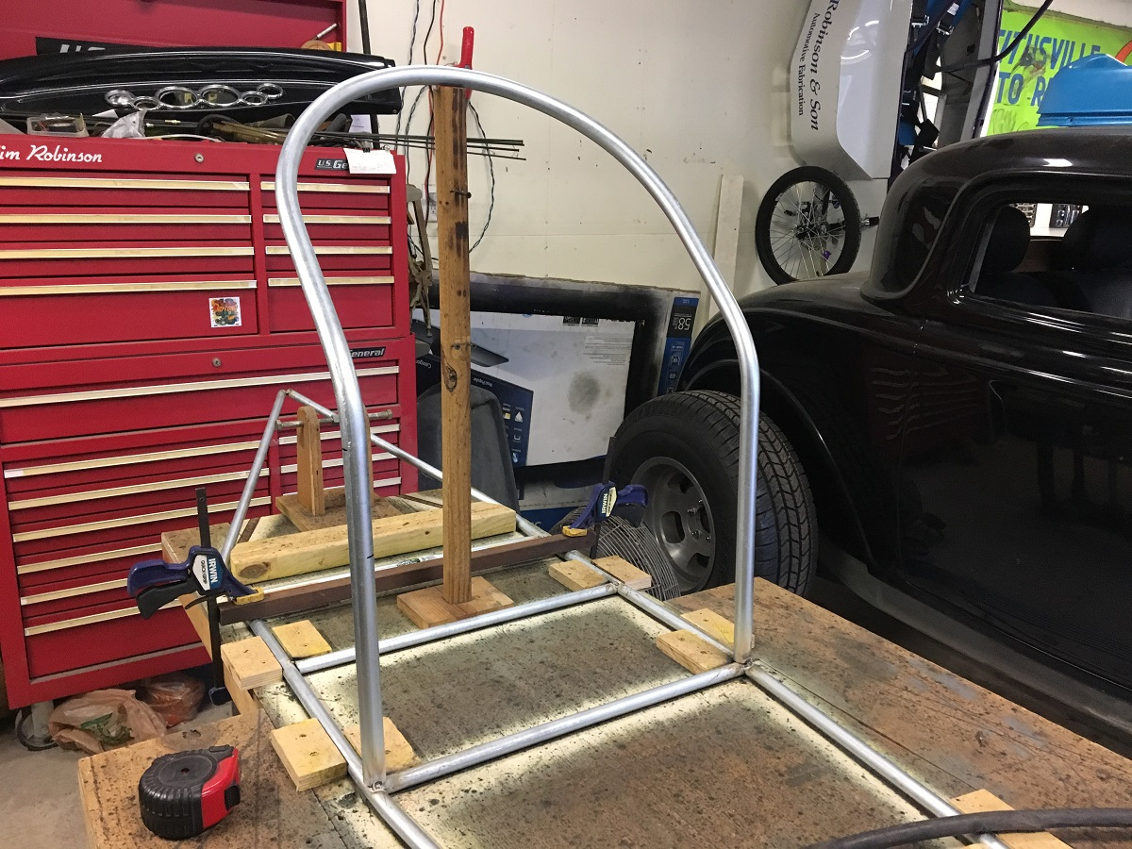

In this next picture you can see the remaining cross members are now put in place. The bottom tubes continue back and are bent together to form the bottom of the streamlined tail. The length is up to the builder and the design, but in this case I removed 6 inches from rhe ends of the conduit’s original 10-foot length before bringing them together. The type of tail (open or streamliner) and the final shape is up to the builder. With the frame clamped down at the rear (see pic), I bend the back end up approximately 9 inches.
After welding the roll cage hoop and crossmembers as completely as possible with the frame still in the jig, remove the whole assembly and use the jig again to shape the top rails for the frame from ½- inch conduit. Keeping in mind that you’re working upside-down now, bend the front similar to the bottom pieces, but leave the ends somewhat longer. With the front ends formed and welded together, bend the conduit to fit in the jig. Finally, tack-weld a temporary crossmember across the conduit a foot or so forward of the roll bar area.

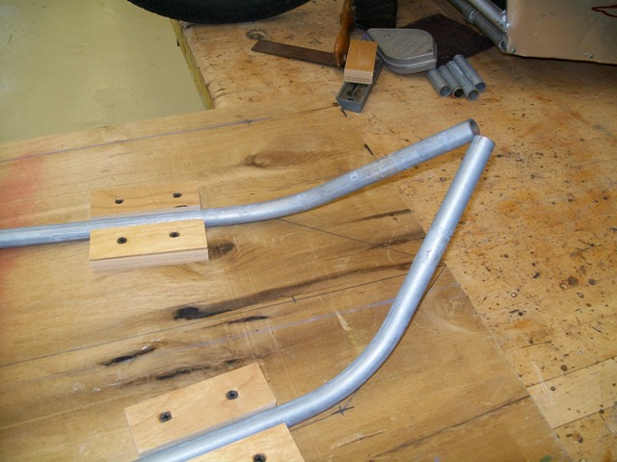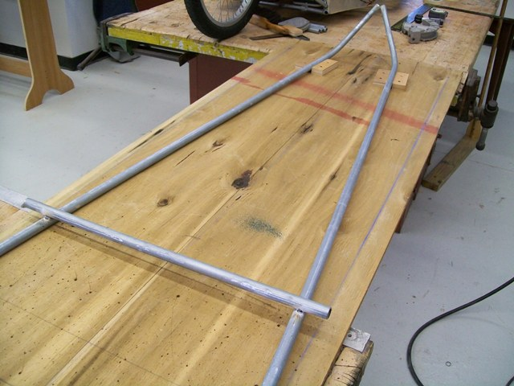

I should have mentioned before that welding galvanized metal can be hazardous to your health if you inhale the fumes. I'm not sure what gasses are generated, but it is my understanding they can make you quite sick and possibly cause nerve damage. I should have warned that welding this material (conduit) has to be done in a well-ventilated area. I usually have a fan blowing toward the work to carry the fumes away and I am careful to not weld in a position that causes the smoke and fumes to come up under my welding hood. I should also mention that conduit is easily notched or "fish-mouthed" with a pair of aviator tin snips or on a bench grinder.
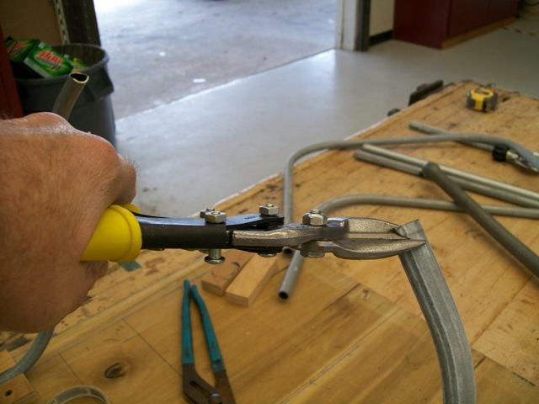
For building cars with the long, streamlined tail, shape and tack-weld the rear ends together. Again, your design could differ, but in my case, I cut 6 inches off the 10-foot conduit before shaping and welding the bottom tubes, but I leave the top tubes full length. I also add a second temporary cross member a foot or so behind the roll bar area. I do this so that the pieces will hold their shape when I cut them apart later. After tack-welding the top frame tubes together at the ends and with temporary crossmembers in place, remove the assembly from the frame jig.

Put the bottom frame & roll cage hoop back in place on the jig and clamp it down. Now the top section can be fit to the bottom. This is a tricky step and is best done with a helper. I don’t have a picture of the process, so go slow and take care… Put marks on the roll bar where you want the top tubes to attach. On my cars it’s 15 ½ inches up from the surface of the jig. Now measure from the welded ends of the tubes at the front to the marks you just made on the roll bar. Don’t try to follow the tubes, just measure straight from point to point. With the top tube assembly lying upside down, measure it the same way from its welded front-end back and mark the tubes. Again, don’t follow the contour of the tubes, just measure straight from point to point and mark the tubes. I suggest measuring several times to be sure of the dimension. Cut the tubes ¼ inch longer than your measured dimension. Now set them together so all four frame tubes come together at the front. Trim the back end of the top tubes as necessary so that they fit correctly at the mark on the roll bar. When satisfied with the fit, tack-weld the ends together at the front and tack the back of the tubes to the roll bar. The temporary crossmember stays in place on the top tubes for now.
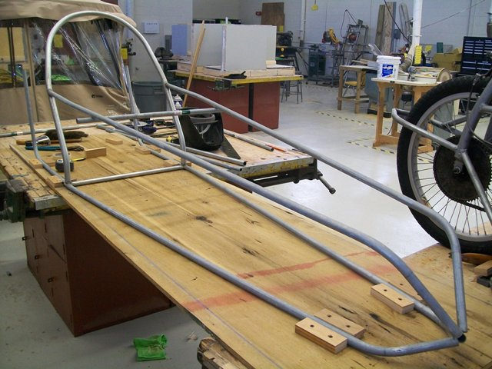

On the open rear cars, the next piece fabricated is the piece that ties the roll cage hoop to the rear of the frame. Bend a simple half-rectangle from ½ inch conduit and fit it behind the roll cage hoop at the same height as the front tubes. Bend the rear upright ends inward to make everything come together. The picture does a better job of explanation than my words... Once satisfied with the fit, weld it in place.

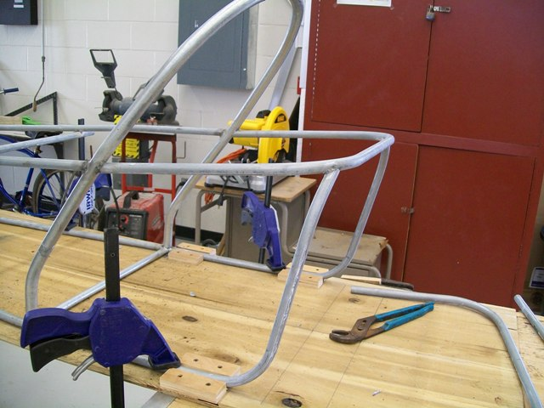

This is the open rear-end style car.

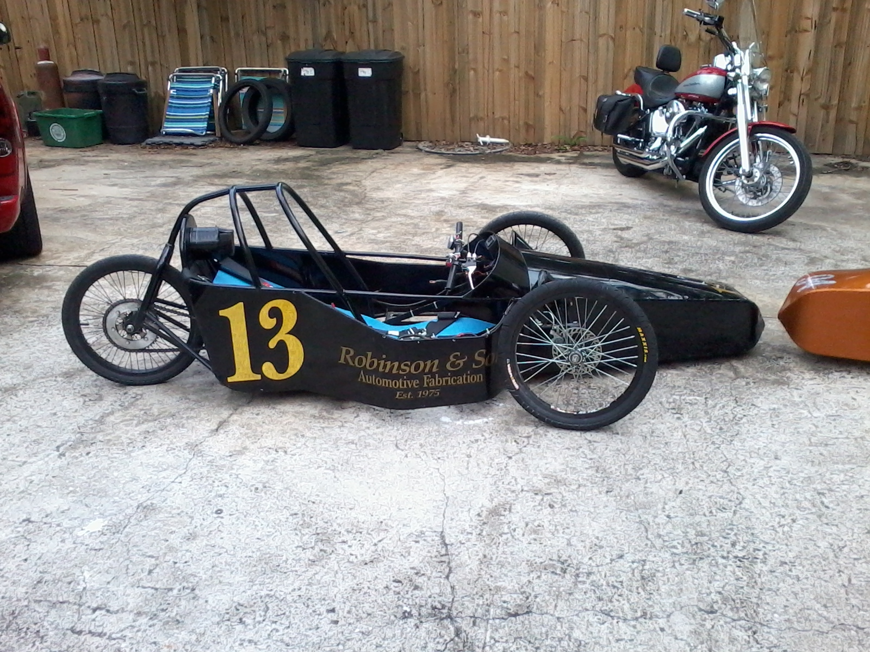

For the streamlined rear, measure and fit the back half of the remaining section from the previous step. It’s much easier with an extra pair of hands; hold it in place and trim the tubes until the rear ends are almost even when checked vertically, but with the top piece about an inch behind the bottom. When satisfied with the fit and appearance, tack-weld the tubes to the roll bar. Measure and cut a piece of ¾ inch conduit (usually about 11-12 inches long) to make a vertical suppoert at the rear. When satisfied with the height of the top tubes, weld the vertical piece in place.

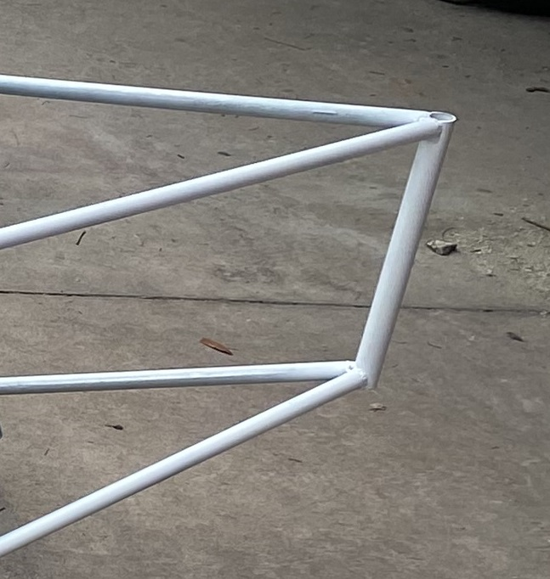

This is the streamlined rear-end style car.

