Chapter 5: Suspension…Or Not

Next on the agenda is to mount the rear "suspension". (I put it in quotation marks because this car really has no suspension; it is rigid.) The rear wheel is mounted using an ordinary bicycle front fork. In these pictures I am using the fork from a 26-inch beach cruiser, simply because that's what I had on hand. On subsequent cars, when I bought new parts, I have used 20 inch forks.
I prepared the fork by opening the axle slots up with a file to accommodate a 14mm diameter bolt because the wheel I will eventually use here has a 14mm axle. Next, I used the outside of the vise to spread the fork open enough to accommodate a rear BMX wheel with sprocket and adapter installed. Then I cut the neck off the fork with a hacksaw.
To mount the fork, I set the frame on blocks at the intended ride height. Then I put a 20-inch wheel in the fork and propped it up in its approximate position. I put a slight bend in a short piece of 3/4 inch conduit and then cut it to fit between the rear roll cage hoop and the top of the fork. It also connects with the top of the headrest hoop. With everything fit in place, I tack-welded the conduit piece in place.
Using a mix of tape measure, combination square, and "calibrated eyeball", I got the rear wheel and fork pretty well lined up and put a healthy tack-weld at the top of the fork. I then removed the wheel and hung a plumb bob from the center of the fork and used the tape measure to make sure the fork was centered and vertical. When I was satisfied with that, I then measured from each side of the fork to the center of the front of the frame. I was already really close on this, but I tweaked the fork until both measurements were exactly the same (as close as could be determined with a tape measure - less than 1/32" difference) and then added two more tack-welds at the top of the fork. Finally, I cut two lower struts from 1/2" conduit and connected the bottom of the fork to the frame at the lower corners. With the struts in place, I checked the measurements one more time and welded everything solid.

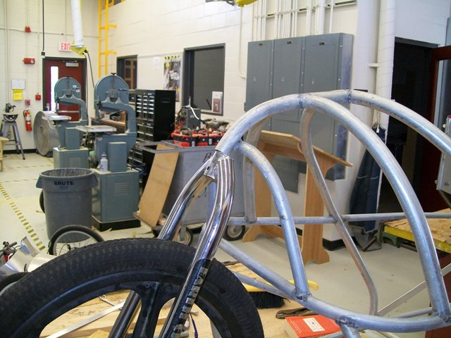
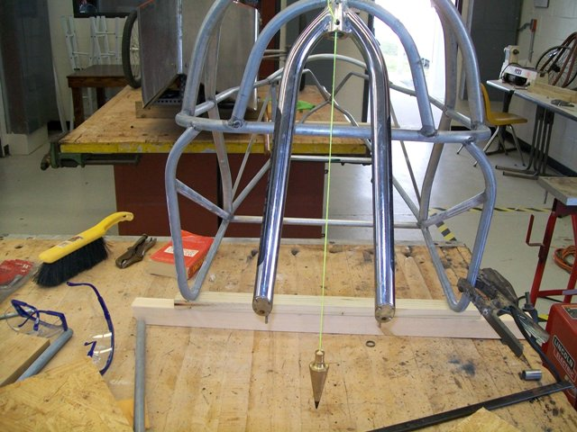

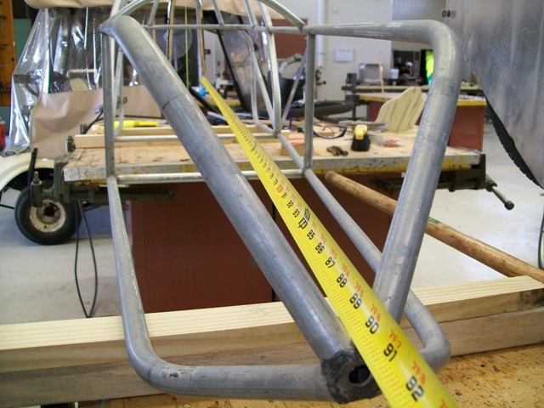

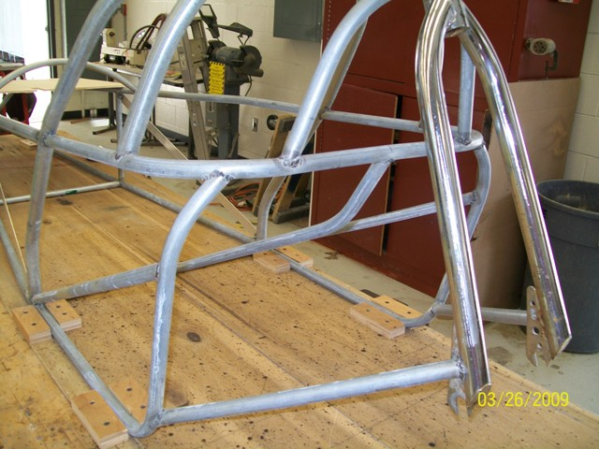

In the last pic above and below here, the center seat back support is visible (arrow). This not only supports the seat back, but also provides an upper support for the motor mount. The motor I'm using requires a “face mount” – a plate that the motor bolts to directly.

