Chapter 6: Frontend

The next part of the build is probably the most difficult part - the front end. Up to now we've been putting pieces together to form the frame. Everything has been welded or riveted and, if it was a 32nd or even a 16th of an inch off, no big deal. The front end, however, includes the steering and we are now dealing with some moving parts that affect steering geometry and rolling friction.
To begin, I put the frame back on the jig and spaced the whole thing up off the table to the intended ride height. I then used a 20-inch bicycle wheel and tire with a bolt through the center to determine where the spindle shafts and, therefore, the ends of the axle would need to be. The way this car is configured, the driver's legs will pass under the front axle. Because of that I had to keep the axle as high as possible in the frame. In order to keep the axle high enough but still get the ends low enough, the axle would need to rise in the center. I put a slight bend in the center of a 34-inch piece of 3/4" conduit, inserted it through the frame and clamped it in place. This would become the main axle tube. After centering it by measuring from both ends to the frame, I welded the tube in place.
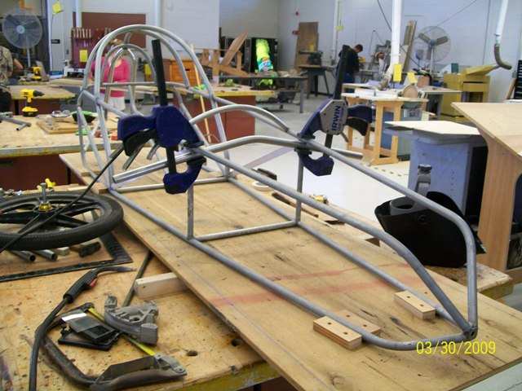

The next thing I did was build a small fixture to hold my king pin bosses in place at the proper height and angle. The bosses are made from 1/2" O.D. 3/8" I.D. tubing that I got at ACE Hardware. The fixture was made from scrap 3/4" plywood. I tilted it in 7 degrees to give me a 7-degree king pin inclination. I also cut the blocks so the kingpin boss would be installed with 7 degrees of positive caster.
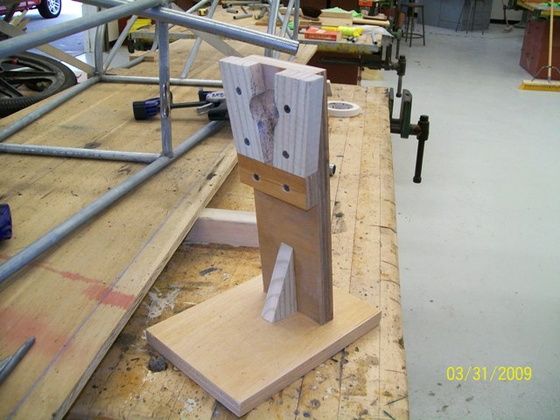

To accommodate the kingpin bosses, the axle tube needs to be notched on top of the ends. I do this with the aviator snips, but it can also be done with a grinder.

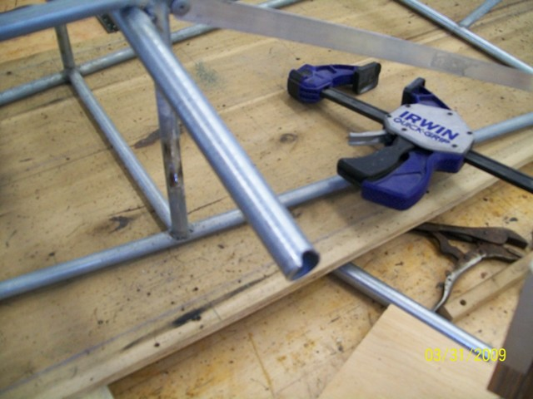
With a kingpin boss clamped in the fixture, I moved it into position tack-welded it in place. I repeated the procedure on the opposite side and then welded them both completely.

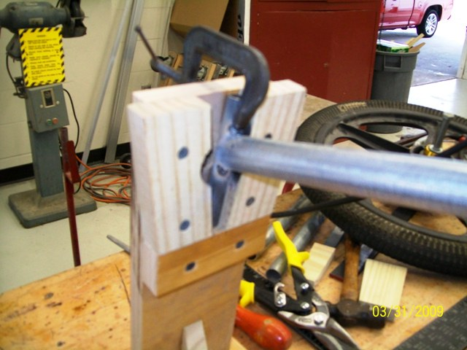

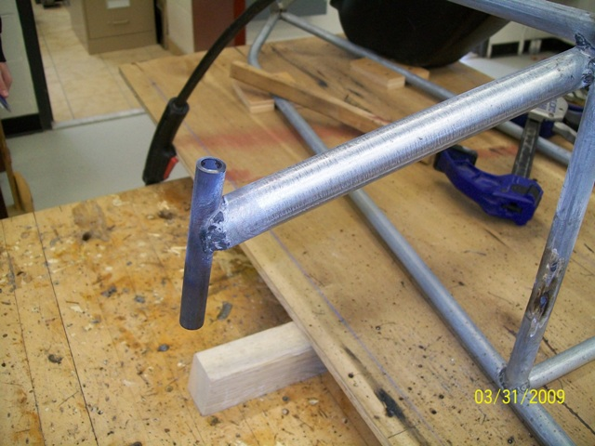
To finish the axle, it needs to be braced. The front end of these cars sometimes take a beating from bouncing off of curbs, running over parking lot drain grates, and an occasional collision. To add the appropriate strength to this axle assembly I bent two pieces of 1/2" conduit to about 60 degrees and then trimmed them to fit between the lower part of the kingpin boss and the vertical frame member. I took care here to make both sides as identical as possible. When I was satisfied with the fit I welded both of them in place.

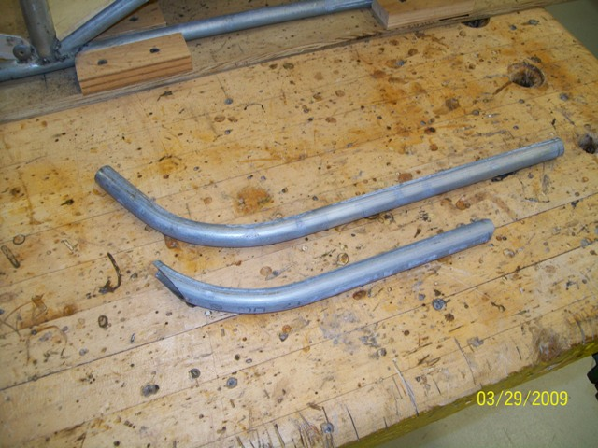

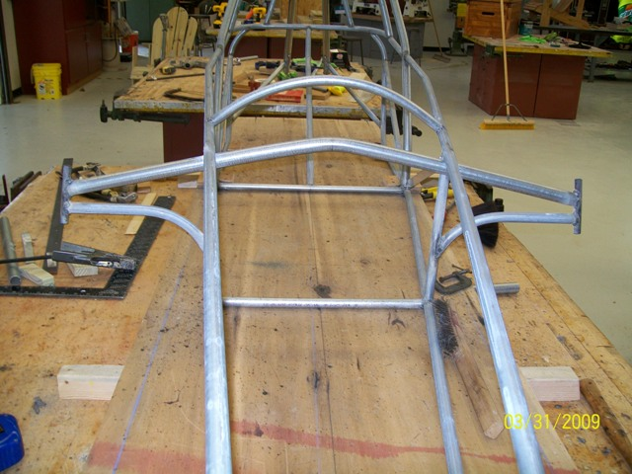
After the first few cars I built and sold, I determined that the curve in the lower braces is unnecessary and only complicates repair or replacement, so in all subsequent cars I have replaced them with a straight piece attached directly from the kingpin boss to the lower end of the vertical frame member. The change is visible in the photo below.
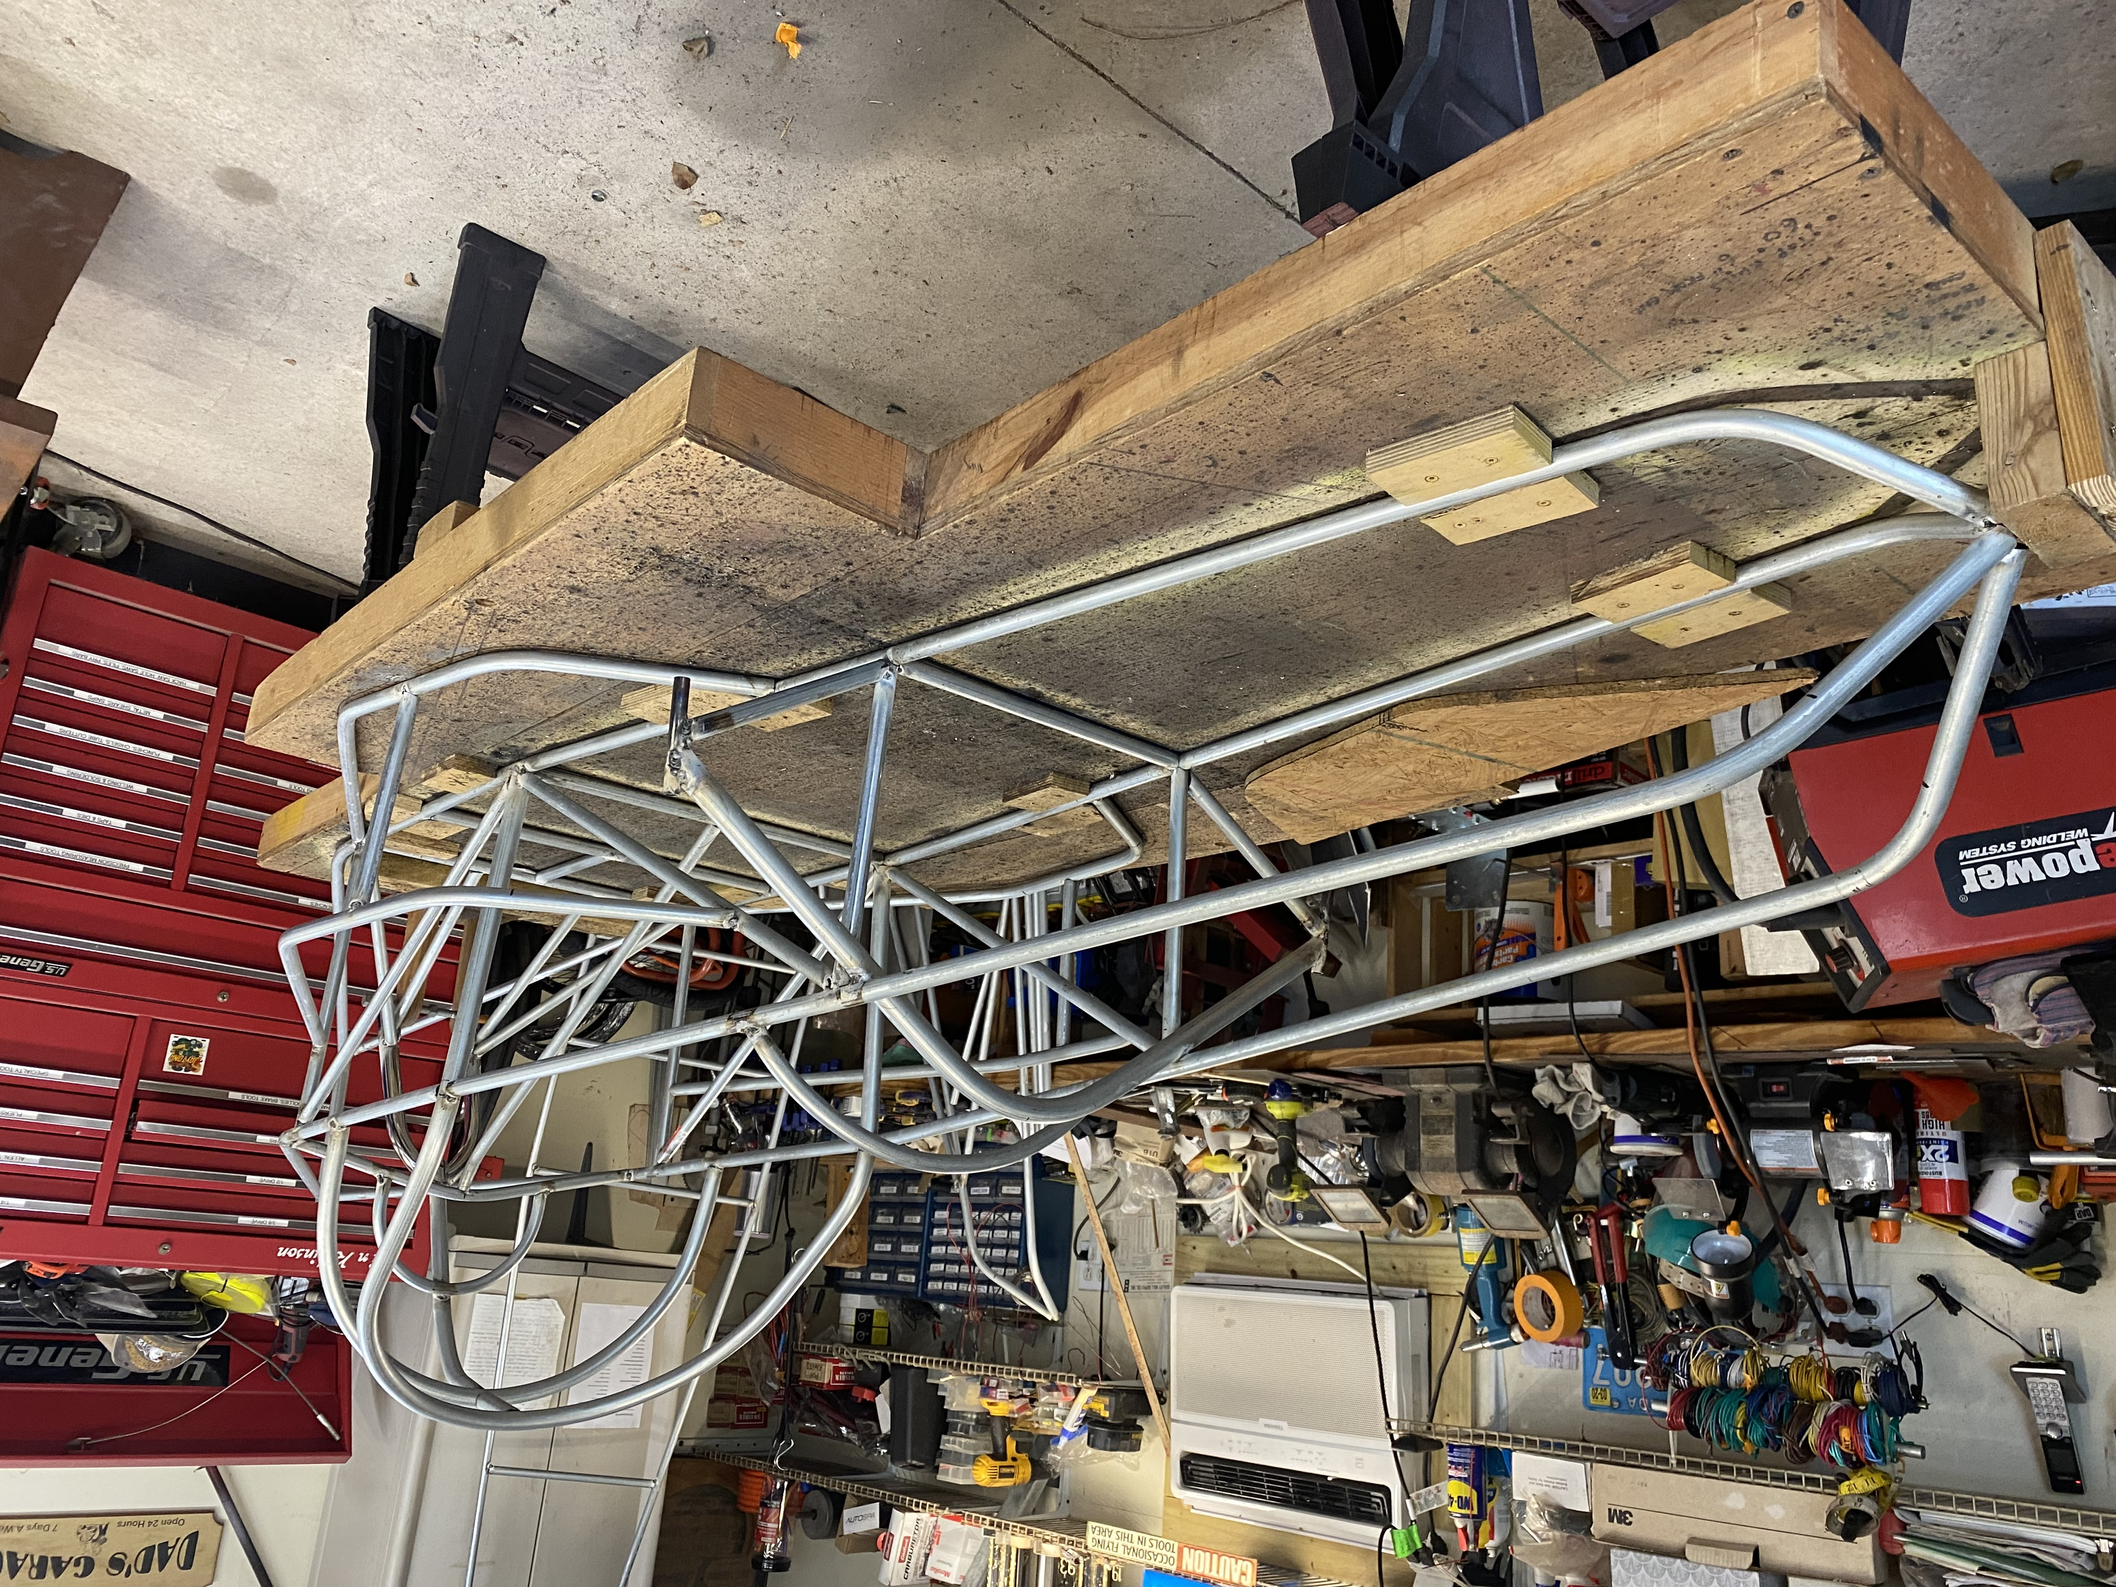

Horizontal bracing of the front axle is purely a matter of personal preference. The reason I don't put lateral bracing on the front axle is because, if it hits something hard enough to cause damage, I would rather just bend the axle tube than transfer the damage to the frame. Once during a race in my orange car (pictured previously), I was cut off going into a corner and simultaneously tangled with the other car and the curb. The left end of the axle was pushed back two inches, but the wheel was undamaged and I was still able to finish. Between the day's events, I was able to straighten the axle and went on to win the second event of the day! Had the axle been laterally braced, it could have caused damage to the frame that might have sidelined me for the rest of the day. As I said, it's a matter of personal preference, but Electrathon usually isn't as "rough and tumble" as Karts (I've raced those, too).

