Chapter 7: Spindles

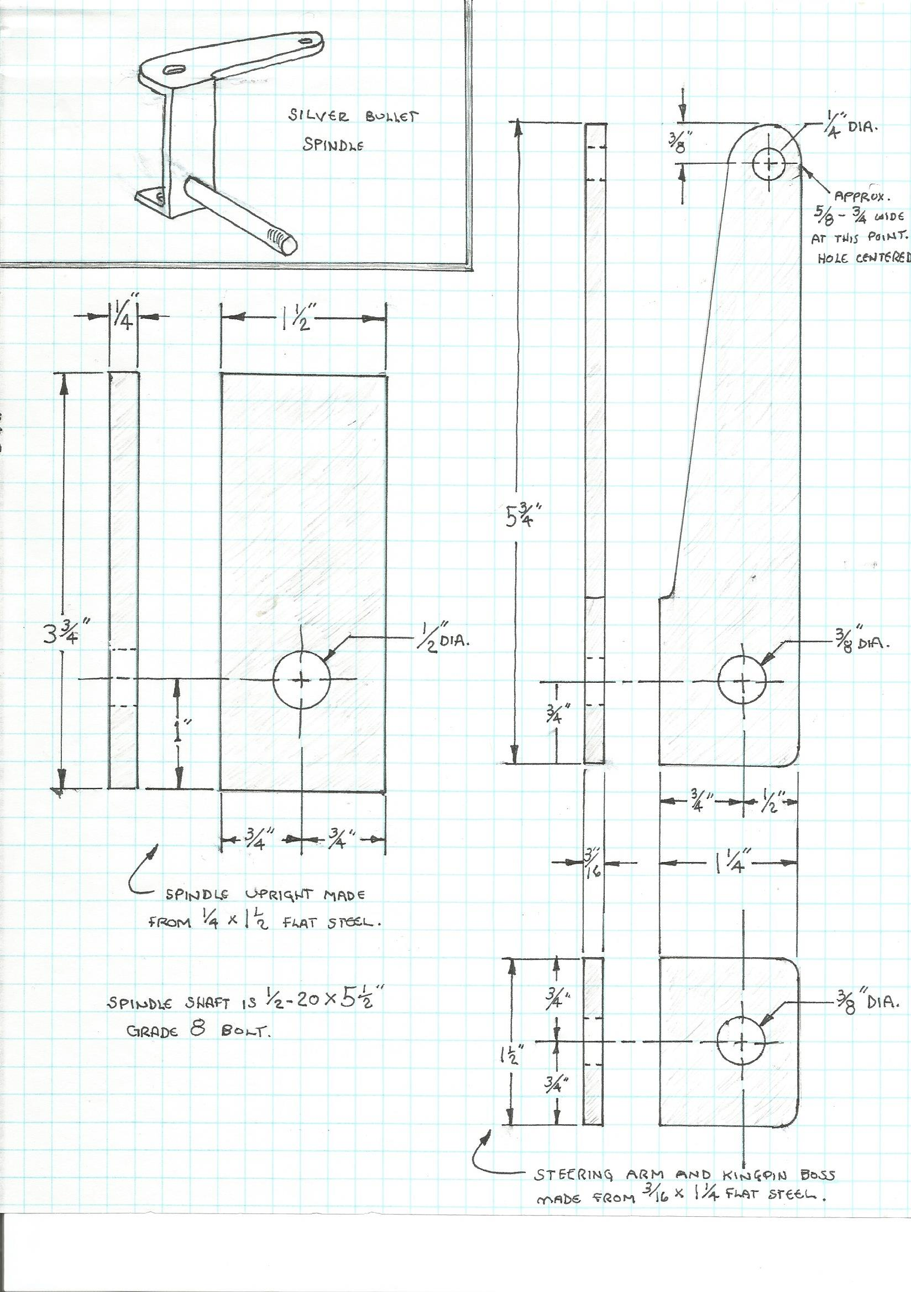
Having built the front axle, the next logical step is to fabricate some spindles. For the knuckles I used 3/16" x 1 1/4" flat steel. The first pieces I fabricated are the steering arms. These pieces also form the top part of the spindle knuckle. No rocket science here, I merely drilled the appropriate holes and then cut & ground the pieces to the shape I wanted. The hole for the tie rod is 1/4", the hole for the king pin is 3/8", and the other holes are 1/2" and are just for appearance and reducing weight. Notice I bolted the pieces together for grinding. That way the two pieces are identical.

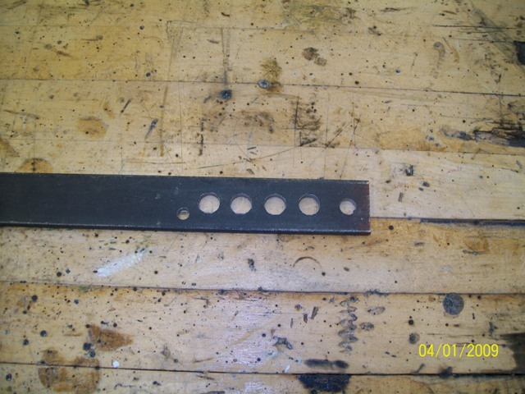

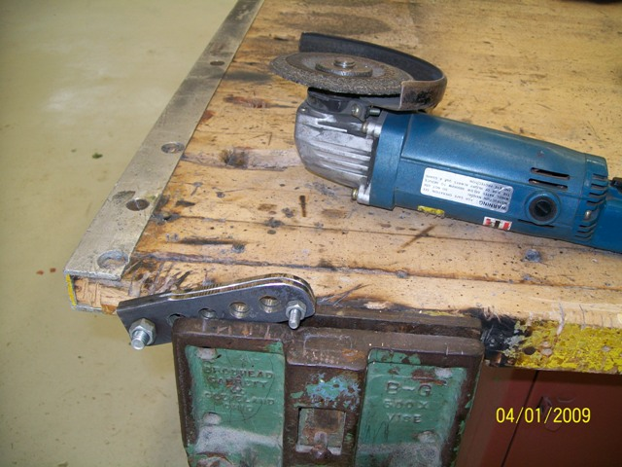
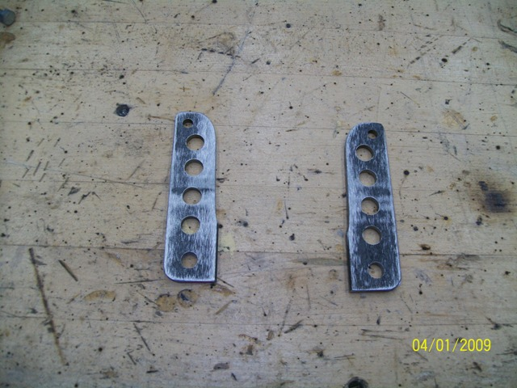

The other pieces are somewhat self-explanatory. The little piece is just the bottom piece of the knuckle. The long piece is made from ¼” x 1 ½” flat stock. It has a 1/2" hole near the bottom where the spindle shaft (a 1/2" x 5 1/2" bolt) will be welded later.

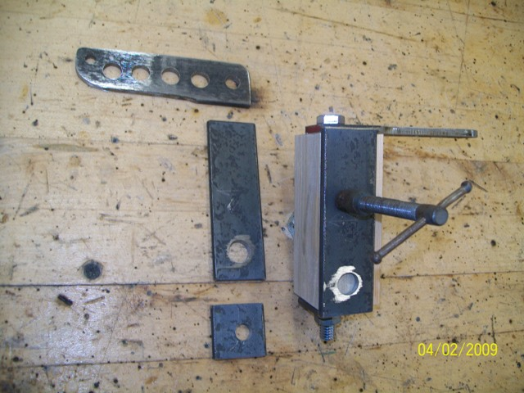

To assemble the spindles, I cut a scrap piece of 2" x 2" lumber on the miter saw. I was careful to make sure the saw was squared so it would cut nice square ends. I then cut the wood 1/16" longer than the kingpin bosses on the axle (kingpin bosses are 3 3/4"; I cut the wood piece 3 13/16"). I bored a 3/8" hole through the wood so I could bolt the knuckle pieces in place and then positioned and secured the outer piece with a clamp. After welding the outside, I removed the knuckle assembly from the wood and welded the inside. I simply repeated the process (using the same wood block) for the other spindle knuckle being careful to arrange the pieces so it would make the opposite side.

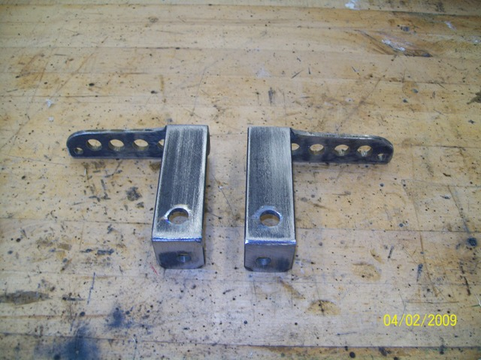

To weld the 5 ½” spindle bolts into the knuckles and assure that they are straight, I used a short piece of conduit as a sleeve and tightened the spindle nut firmly against it. Then I welded the head of the bolt to the back side of the knuckle. The sleeve not only assured that the bolt was installed straight, but also protected the bolt & threads from the welding spatter.
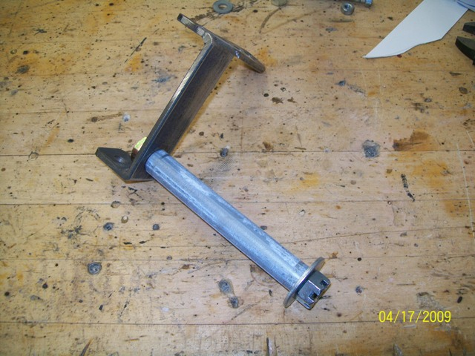
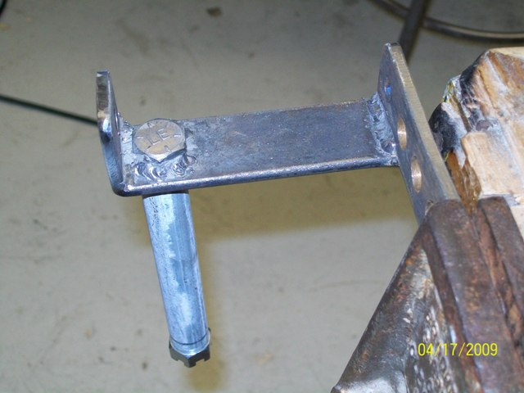

The wheels I am using on the front of this car had to be specially assembled for me. They are 20-inch wheels with mountain bike hubs that accept disc brake rotors. At the local bicycle store, the proprietor and I selected a mountain bike hub that has sealed bearings and disc rotor mounting holes. Then I picked out a double wall alloy rim and the bike shop guy called his supplier and ordered them for me. $85 per wheel (in 2009- ouch!) and two days later I got these (pic below). Since this build (2009) I have learned how to lace my own wheels and I have improved my wheels by using 12-gauge spokes. (More on that later) The hole through the center of these (20mm) is about a half millimeter larger than 3/4". The disc and brake caliper were not included in the $85; they are sold separately.
At the local ACE hardware store I found some bronze Oilite bushings that are 3/4" O.D. and 1/2" I.D. The perfect solution for putting 3/4" hole bearings on 1/2" diameter axles. I failed to take a pic of them separately, but the bronze shoulder is visible here behind the nut.
