Chapter 9: Mounting the Motor and Batteries

Well, it's finally on its own 3 wheels. Next up... the motor mount!

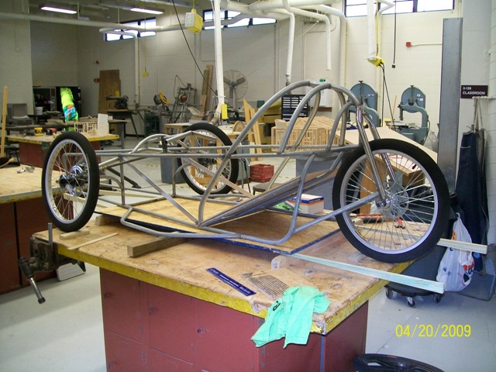

OK, first step to mounting the motor is to mock it up in position. I am using either a Briggs & Stratton Etek motor or a Motenergy ME-909 here (Yes, Briggs & Stratton made electric motors! The Etek was discontinued in 2006). After situating the motor where I wanted, I added two crossmembers in the frame and then a short longitudinal (front to back) piece to support it. That short piece is located exactly in the center of the chassis so it is in line with the seat support directly above it. When the mount is in place, the motor will bolt to the left side of it.

(Just to be clear, any time the terms left and right are used in automotive parlance, it refers to left and right as referenced from sitting in the driver’s seat. The left side of a passenger car or truck is the driver’s side, the right side is the passenger side.)
After the crossmembers and longways piece were welded in place, I next fabricated the motor mount plate. The plate is made from 1/8-inch plate steel, 5 inches wide and 15.5 inches long. I used a piece of card stock or poster board to copy the bolt hole pattern on the motor and then transferred it to the steel plate. After drilling the 3/8-inch diameter holes, I put a bolt through the bottom rear hole of the pattern and the plate and rotated the pattern forward approximately 3/4 inch. I marked the new location of the other holes and drilled them, too. Then I used a die grinder and file to elongate the three pairs of holes into slots. The picture does a better explanation of what I did. The slotted holes allow for chain tension adjustment. After the first couple of cars, I started having a friend with a milling machine make the mounts for me. I have used a combination of old and new pictures here, so that’s why it looks like two different mounts – it is!

The first picture below is one of the newer milled pieces. Some of the other pictures are of the older hand-made mount. It merely shows that they do the same thing regardless of how they were made. If you look ahead at the second picture you can see the slotted holes are a little rough.

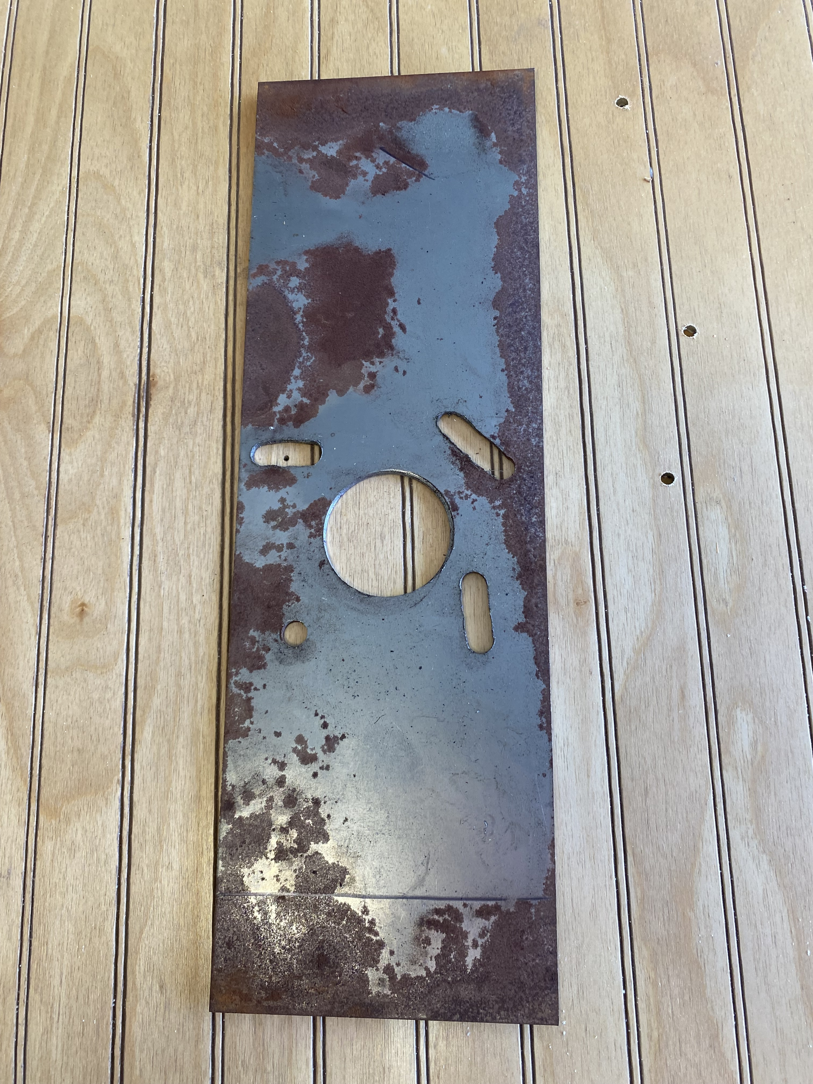

The picture above shows a line across what ultimately would be the bottom end of the mounting plate. I needed to cut that bit off to get the motor to sit at the correct height. You will want the motor to sit as low as practical to keep the weight down low and not interfere with the seat back, but never so low that it hangs below the frame.

After determining the height of the motor and mocking it in place with the mount bolted to it finger tight, I marked it to match the angled center seat support tube. I removed the motor and plate, separated the mount plate from the motor, and cut it off where I had marked. Next, I cut pieces of ½-inch angle iron to fit each edge and welded them to the face of the mount plate. You could also use ½-inch square tubing if you prefer. Whichever you choose, make sure they don’t interfere with the bolt holes in the plate. These pieces are for reinforcement – without them, the motor plate will flex under acceleration and the drive chain will come off. They are visible in the next picture of the finished mount. When the mount plate is finished, tack-weld it in place and do a final trial fit of the motor – two finger-tight bolts is enough. If everything fits as intended, remove the motor again and weld the mount plate solidly in place.

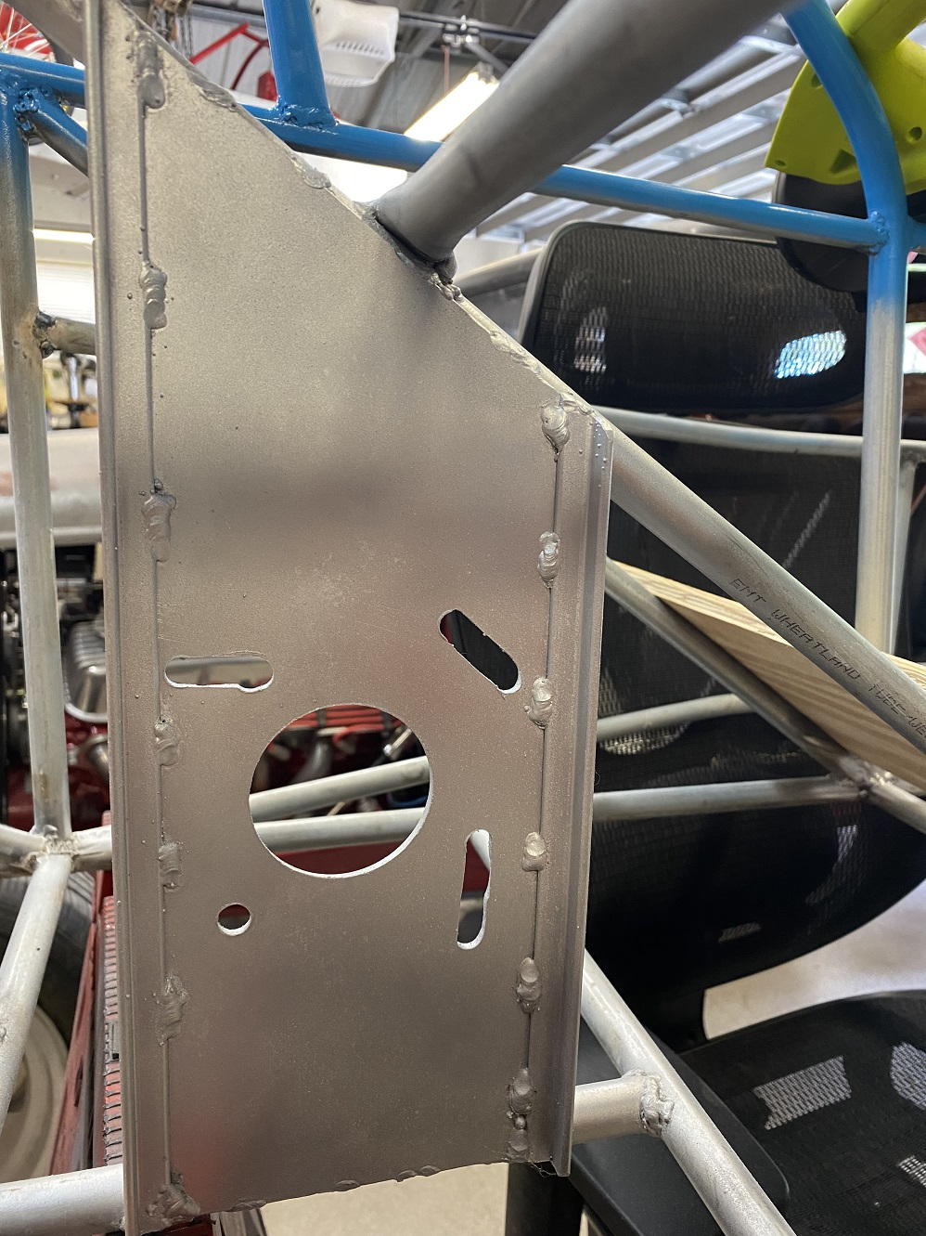

In order to use an electric motor, an electronic motor controller is necessary. Without some type of controller, the motor would either be full-on or off; there could be no intermediate speed, no smooth acceleration, no real control. A mechanical potentiometer big enough to handle the amperage of two Optima batteries in series would be HUGE and heavy. Electronic controllers do the same job, but are substantially smaller and lighter than a mechanical potentiometer. They use a very low power electronic circuit to control the main power circuit. Although controllers can get expensive, the one I am using on this car was a remanufactured Scott controller that I bought a few years ago for $160. Also, sometimes used controllers can be had very inexpensively through golf cart service places. When they get “touchy” at low speeds they are removed and replaced (Little old ladies who play golf don’t like golf carts that have sudden or jerky starts.), but they may be fine for Electrathon.
I locate the controllers near the motor, but far enough away so if the car ever throws a chain it won't be likely to whip the controller. Mounting it was simple; I just fabricated a couple of tabs that match the bolt holes on the controller and welded them to the rear crossmembers. On some later builds I used an aluminum plate cut and drilled to mount the controller and riveted it in placwe with big-head 3/16 pop rivets.

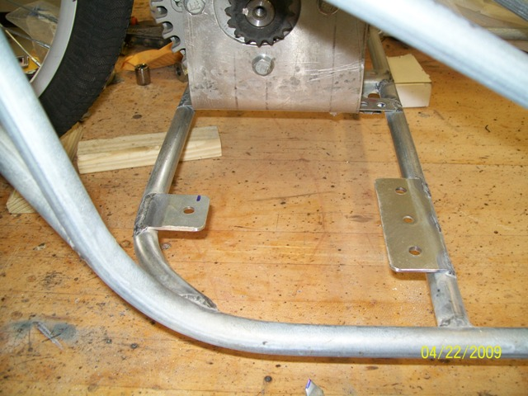

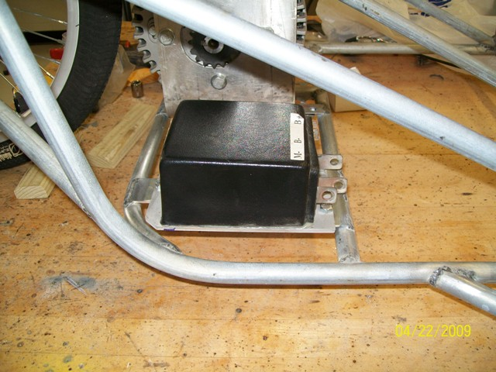

With the motor and controller mounted, it’s time to move on to mounting the batteries. On this car I made trays to mount two Optima Yellowtop batteries, one on each side (24 volt system). Sometime later I built a car that used three Interstate batteries (36 volt system). The process is the same, just the dimensions were changed. Because the motor hangs on the left side of the motor mount, I mounted two batteries on the right side and one on the left.
On the silver car and orange car pictured at the beginning of chapter one, I used 18-gauge perforated steel angle to make the battery trays. For all the cars since, I decided to do something different (and lighter?)...
I now use 1/16" wall, 1" aluminum angle (available at the local ACE Hardware, True Value, Lowes, and Home Depot). I don't have access to a TIG welder, so I used 3/16" pop-rivets. I cut a piece of angle long enough to go around the perimeter of the battery bottom, allowing 1/4" clearance both directions. I drilled a 3/16" hole through the fillet of the angle where the bends would be and then made a cut from the edge of what would be the bottom to the hole (see pic). Then I made the bends in a vise with the bottoms of the corners and the ends overlapping. After checking and adjusting for square, I also riveted the bottom of all four corners.
I made eight mounting tabs (four for each tray) from 1/8" x 3/4" flat steel. I drilled and riveted the tabs to the battery trays and then welded the assemblies in place from the bottom of the chassis.

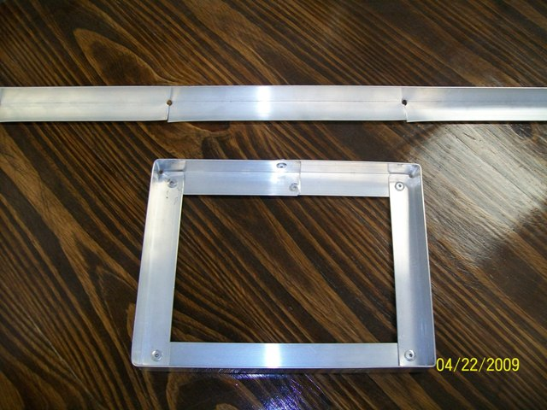
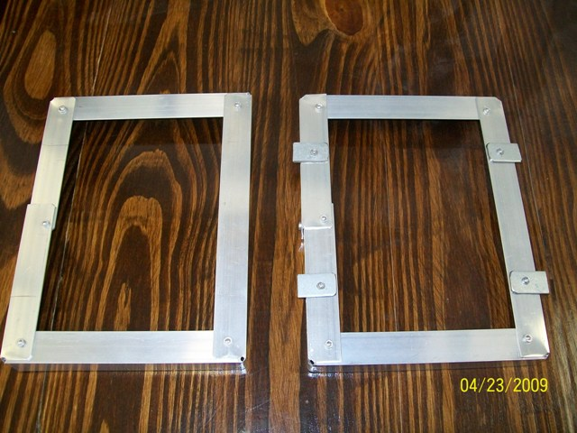

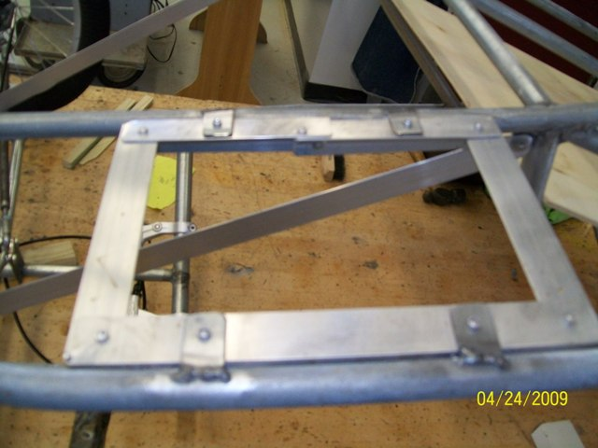

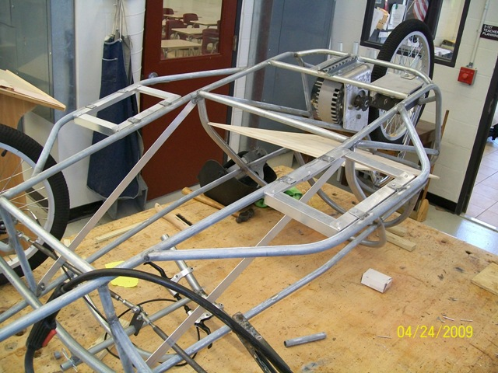

Because of the weight of the batteries, the bottoms of the side pods need additional support along the outside. On this original car I used 1/8" steel round stock (welding rod) to make a pair of diagonal struts for each battery pod. The upper edge of the side pod bodywork was held in place with 3/8 automotive fuel line! When the first few cars started having breakage of the fuel line tubing due to ordinary vibration, I switched to using ½ inch conduit instead (see pic below). The weight difference was negligible and the breakage problem was eliminated.

